**The Art Gallery Database System Phase 3 Report**

Jie Lu, Juanjia Yuan, Shiran Guo, Ruiqi Chen

11/15/2019

**PART A**

**1.1 Revised Entity-Relationship Model**

Entity Relationship Diagram for Art Gallery Database

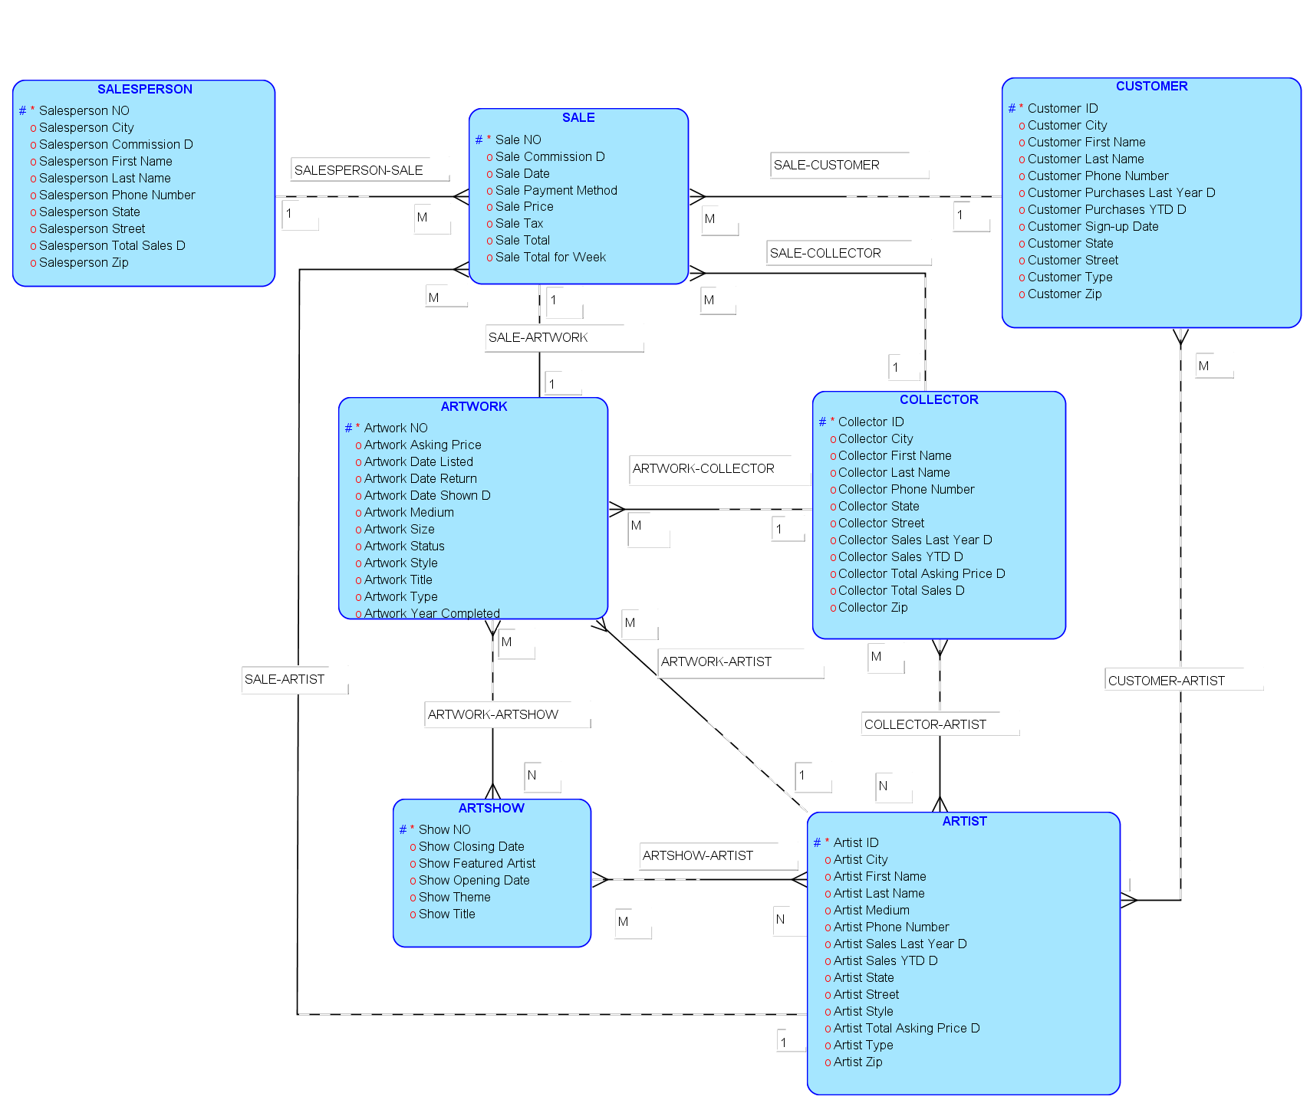

**1.2 Data Dictionary for Entity Relationship Diagram**

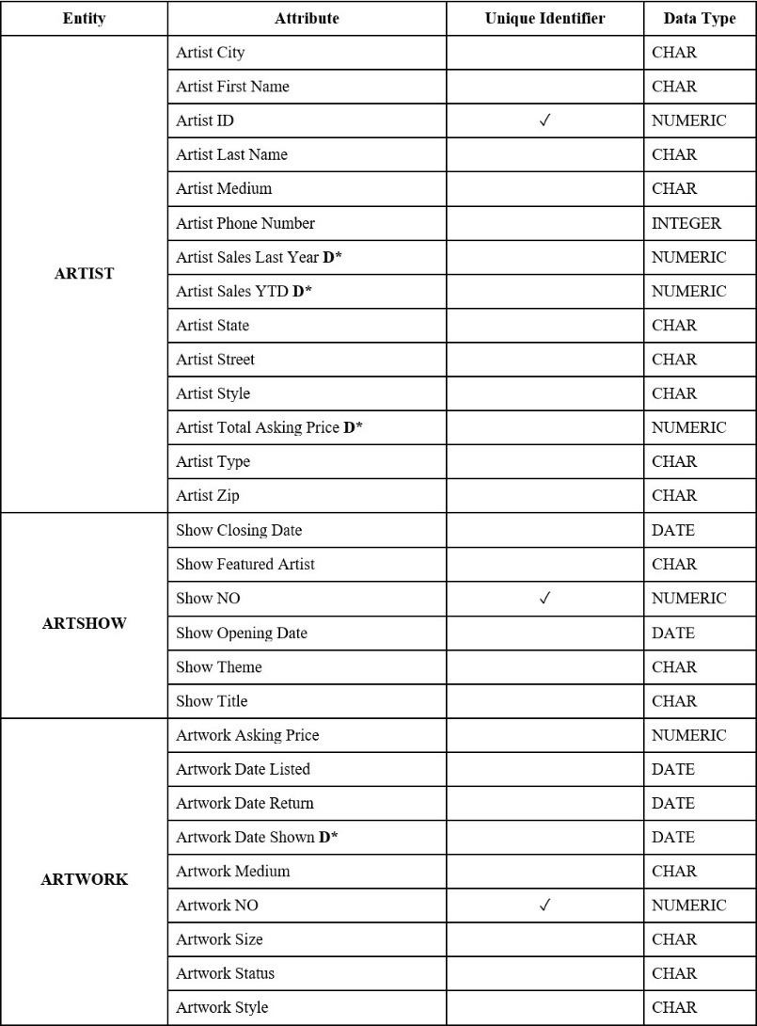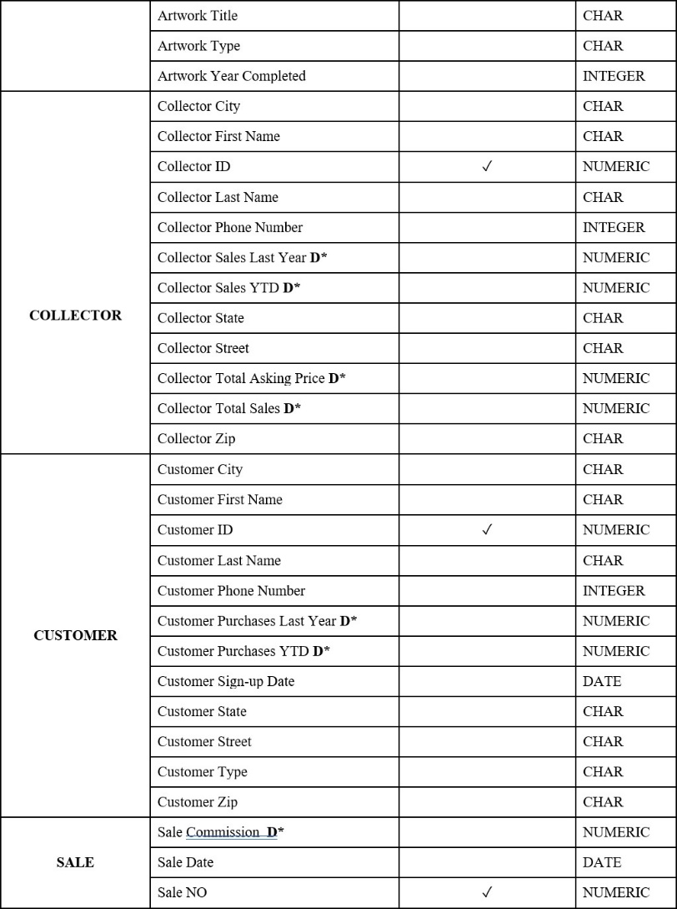

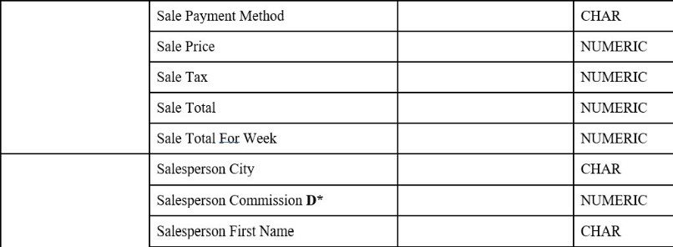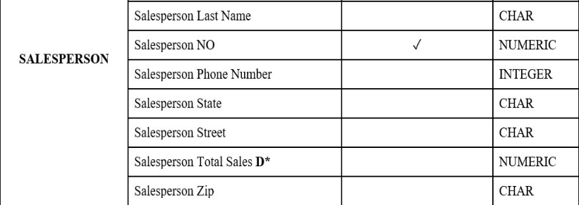

**1.3 Assumptions for Entity Relationship Diagram**

1. “Artist Sales Last Year **D**” and “Artist Sales YTD **D**” are descriptive attributes between “SALE” and “ARTIST”.
2. “Artist Total Asking Price **D**” is a descriptive attribute between “ARTIST” and “ARTWORK”.
3. “Artwork Date Shown **D**” is a descriptive attribute between “ARTWORK” and “ARTSHOW”.
4. “Collector Sales Last Year **D**”, “Collector Sales YTD **D**” and “Collector Total Sales **D**” are descriptive attributes between “COLLECTOR” and “SALE”.
5. “Collector Total Asking Price **D**” is a descriptive attribute between “COLLECTOR” and “ARTWORK”.
6. “Customer Purchases Last Year **D**” and “Customer Purchases YTD **D\***” are descriptive attributes between “CUSTOMER” and “SALE”.
7. “Sale Commission **D**”, “Salesperson Commission **D**” and “Salesperson Total Sales **D**” are descriptive attributes between “SALE” and “SALESPERSON” .
8. There will be only one Artwork and one Salesperson involved in one Sale.
9. One artist only has one major medium and one usual type.
10. We only record one major phone number for each collector, salesperson, artist and customer.
11. Collector can sale and purchase artwork When a collector purchase artwork, he/she will be recorded as Customer.
12. Collector and Customer can be the same person.
13. Sale Commission is charged by the gallery is 10% of the Sale Price.
14. The gallery splits the commission with the salesperson who makes the sale.

**PART B**

**2.1 Default Relational Model**

Default Relational Model for Art Gallery Database

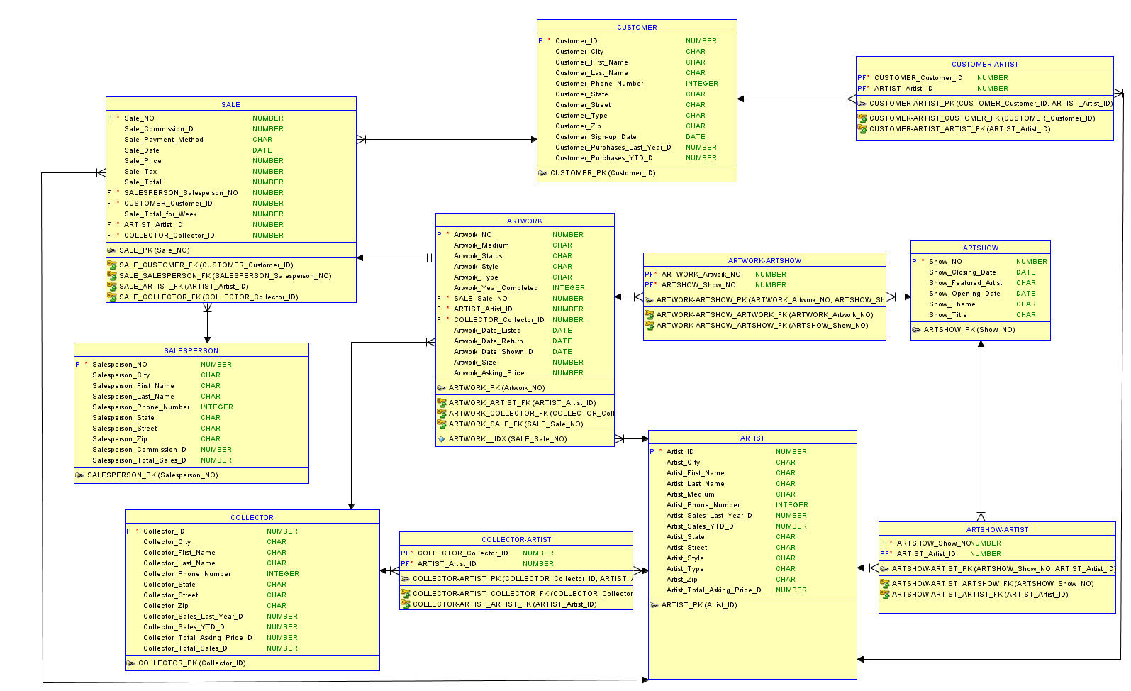

**2.2 Revised Relational Model**

Revised Relational Model for Art Gallery Database

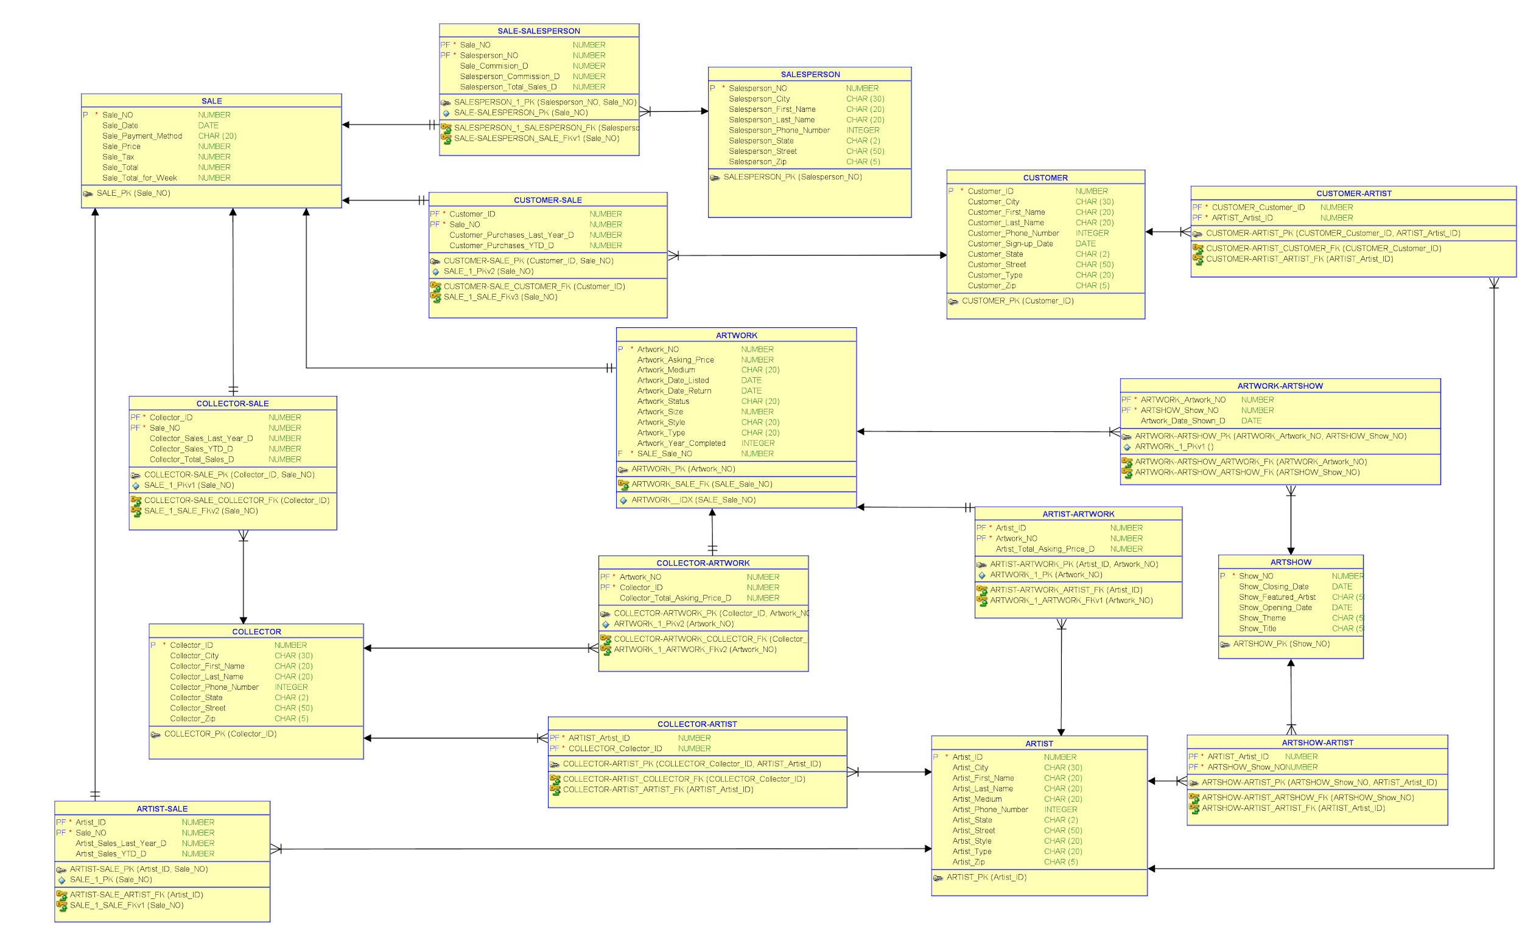

**2.3 Normalization**

Normalized Relational Model for Art Gallery Database

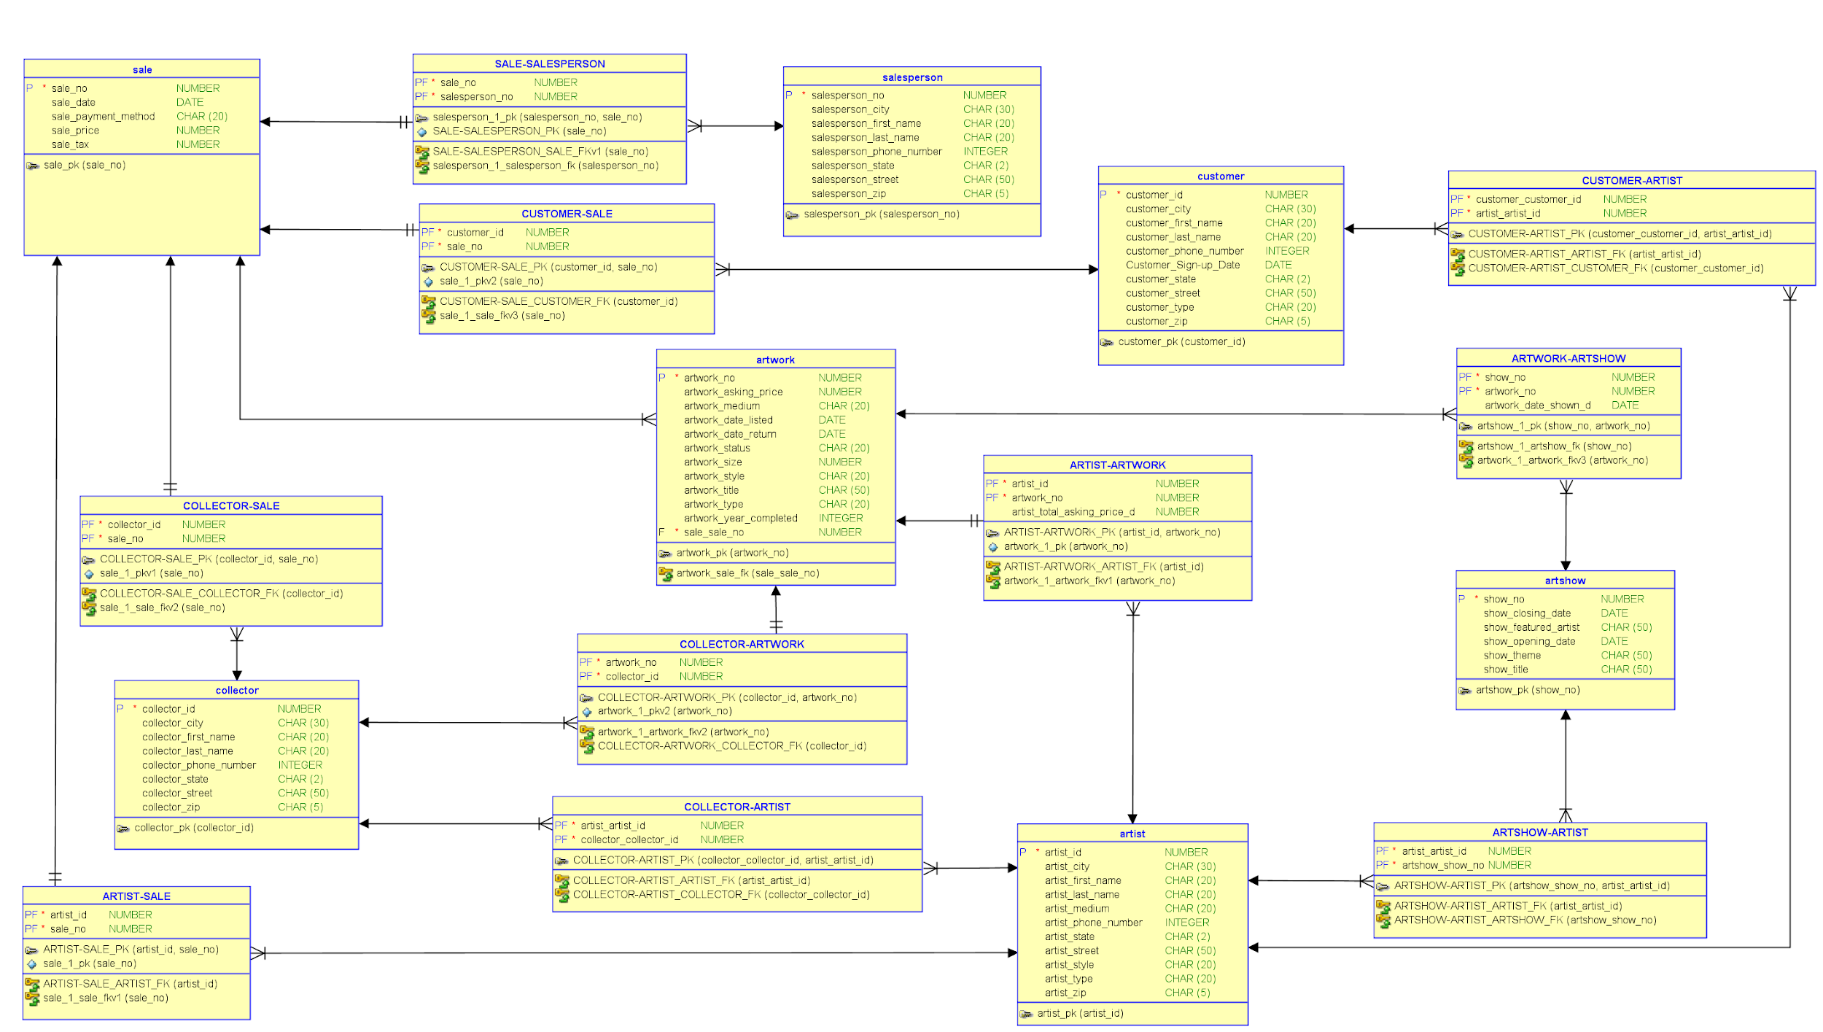

**2.4 Data Dictionary for Normalized Relational Model**

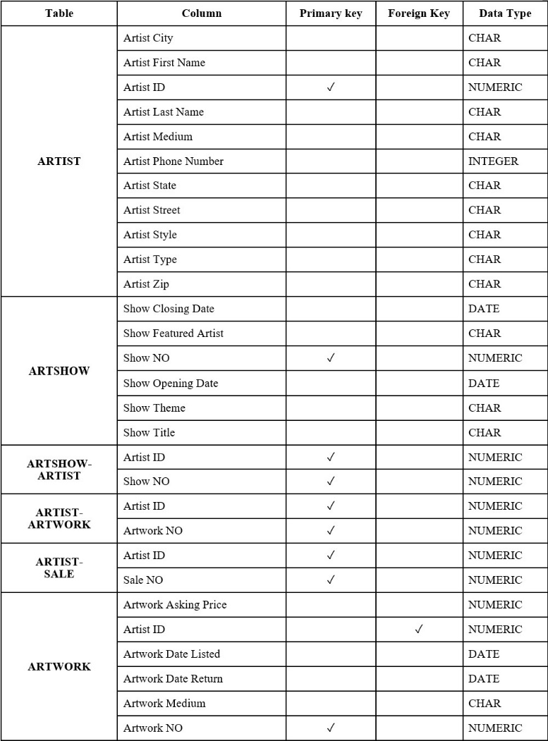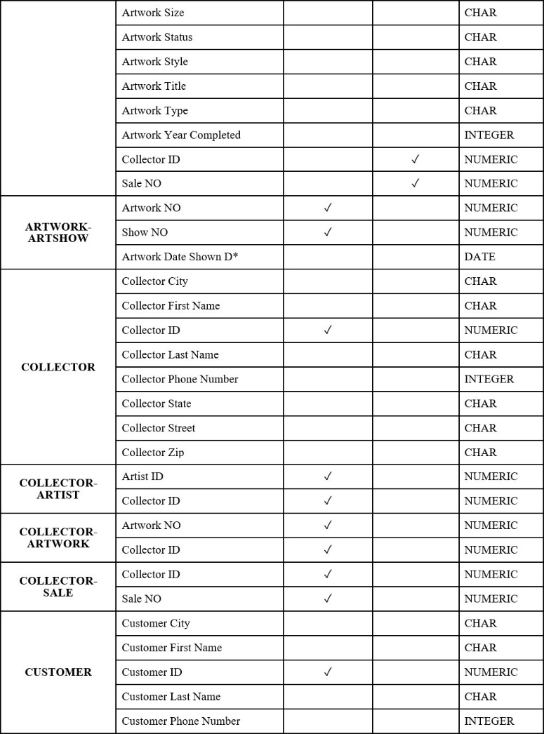

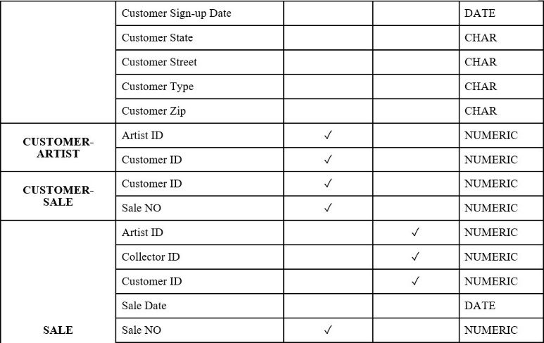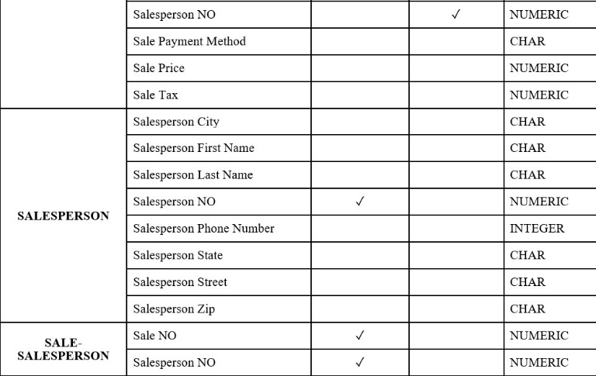

**2.5 Assumptions for Normalized Relational Model**

1. Artist Sales Last Year = sum{Sale Total}
2. Artist Sales YTD = sum{Sale Total}
3. Artist Total Asking Price = sum{Artwork Asking Price}
4. Collector Sales Last Year = sum{Sale Total}
5. Collector Sales YTD = sum{Sale Total}
6. Collector Total Asking Price = sum{Artwork Asking Price}
7. Collector Total Sales = sum{Sale Total}
8. Customer Purchases Last Year = sum{Sale Total}
9. Customer Purchases YTD = sum{Sale Total}
10. Sale Total = Sale Price + Sale Tax
11. Sale Total For Week = sum{Sale Total}
12. Sale Commission = 10%*Sale Price
13. Salesperson Commission = 50%*Sale Commission
14. Salesperson Total Sales = sum{Sale Total}
15. “Artwork Date Shown **D**” is a descriptive attribute between “ARTWORK” and “ARTSHOW”.
16. One artist only has one major medium and one usual type.
17. We only record one major phone number for each collector, salesperson, artist and customer.
18. We consider each artwork’s major medium as its medium.
19. Each artshow only has one major theme.
20. An artwork doesn’t have to be displayed on the opening date of the show. It can join the show any time before the show ends.
21. Collector can sale and purchase artwork When a collector purchase artwork, he/she will be recorded as Customer.
22. Collector and Customer can be the same person.

**PART C**

**3.1 DDL script**

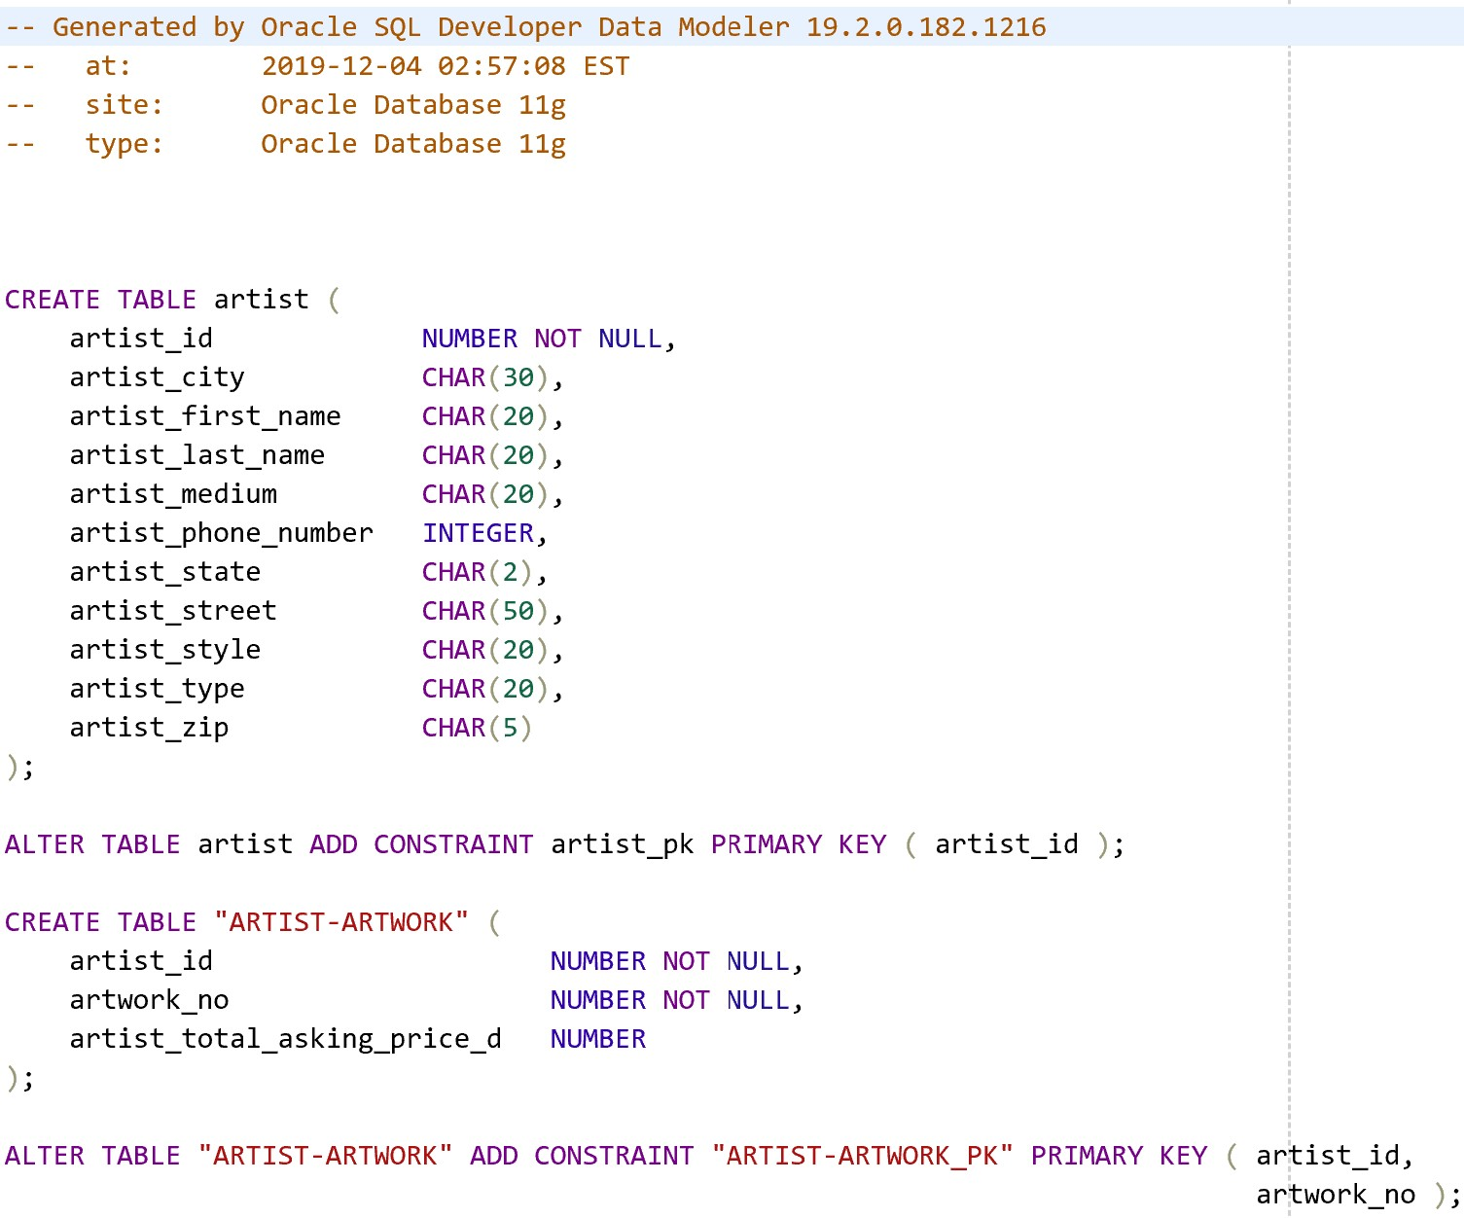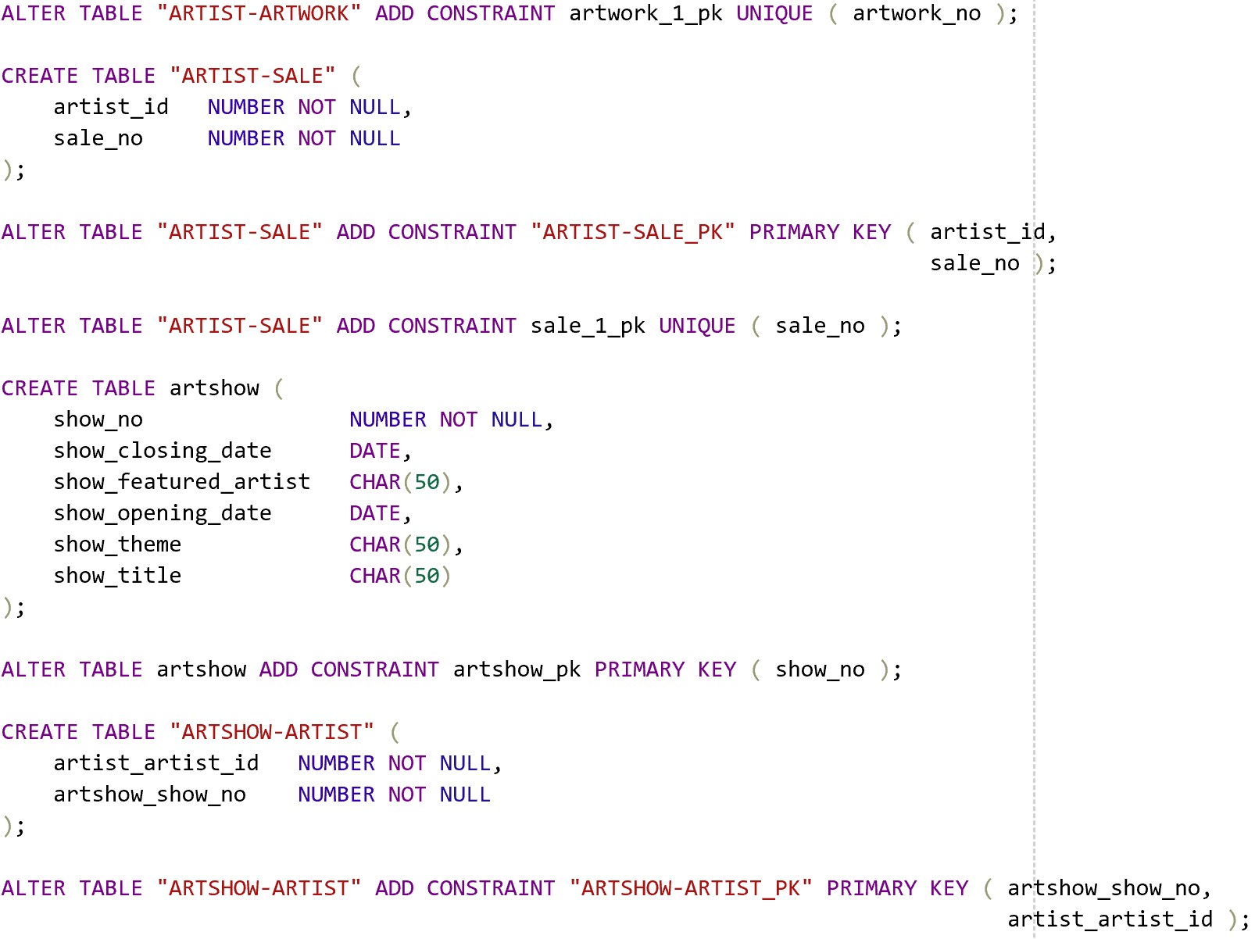

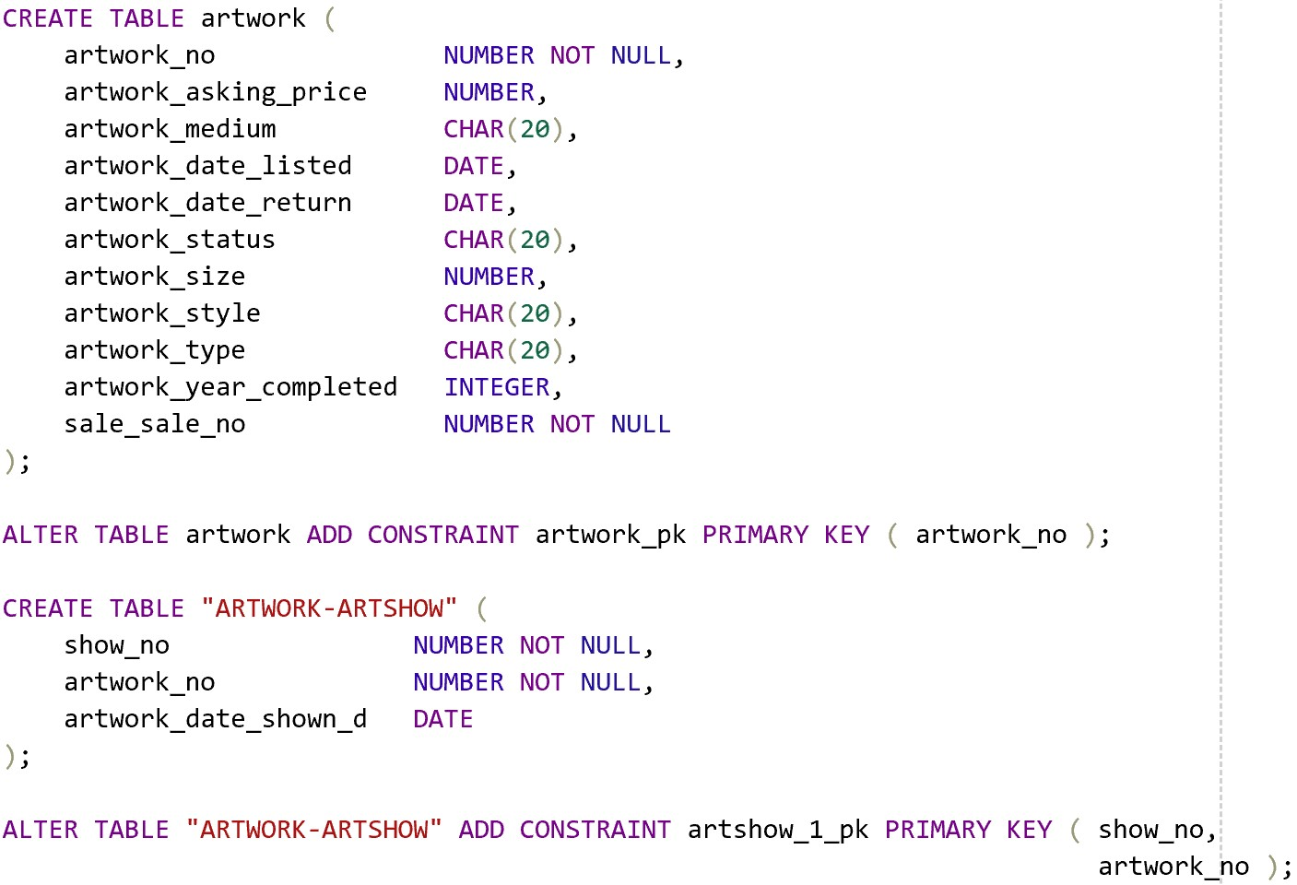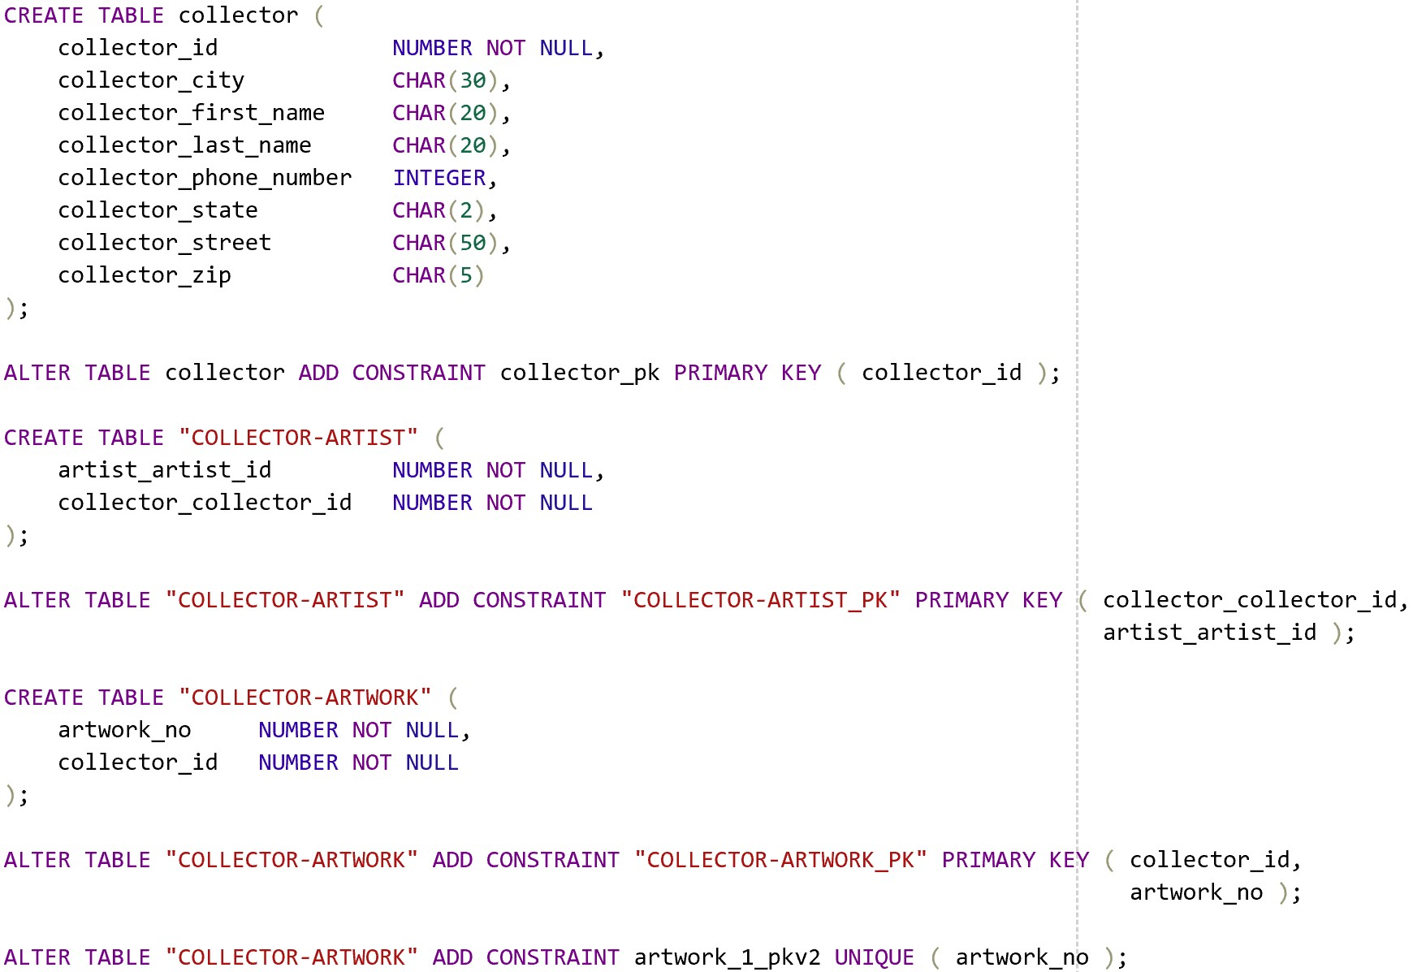

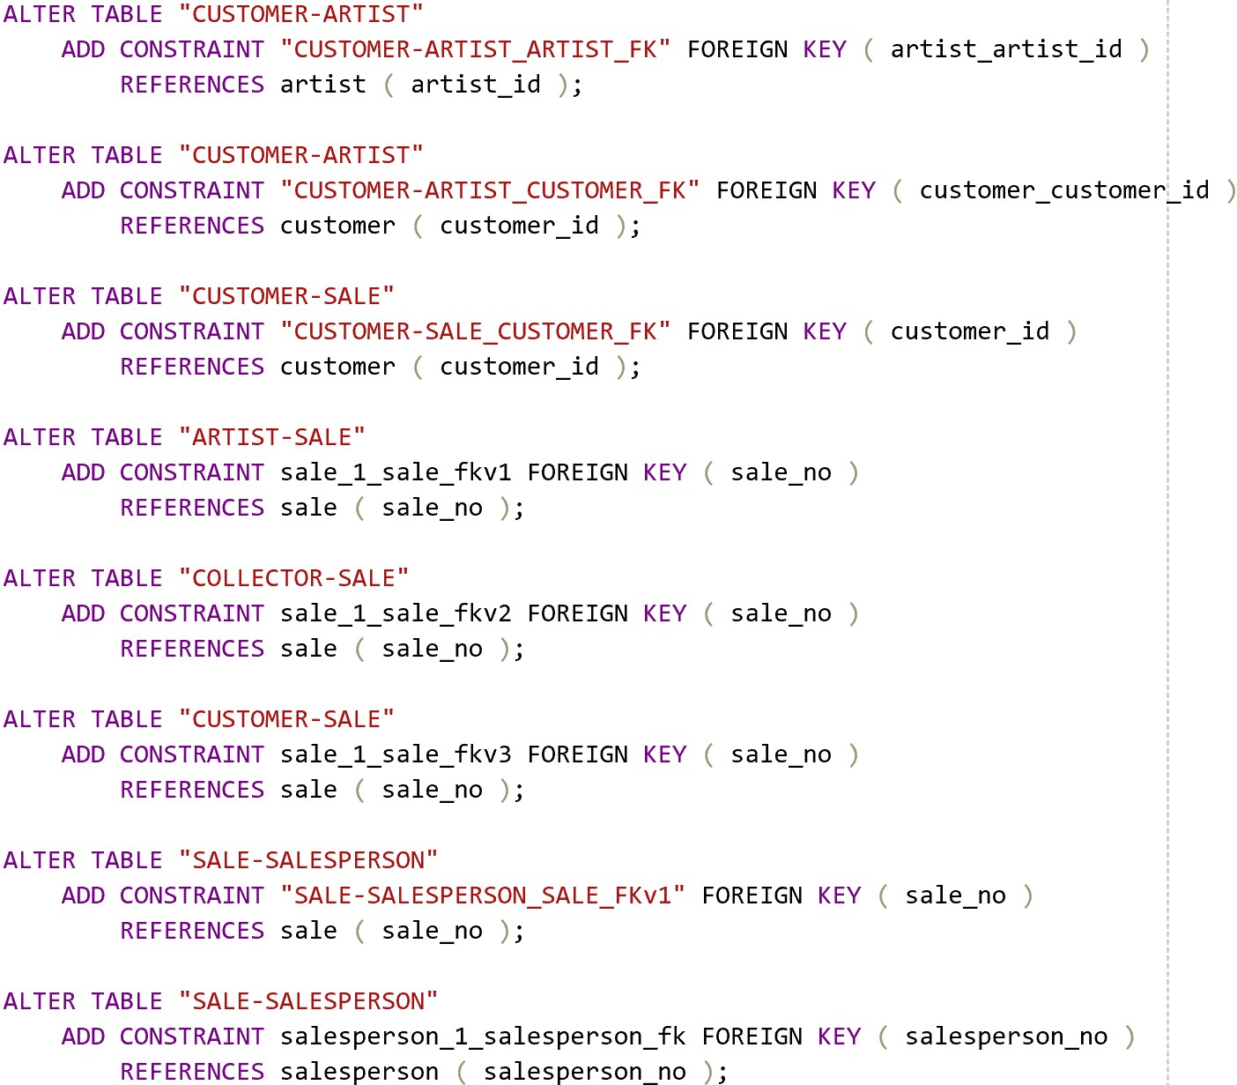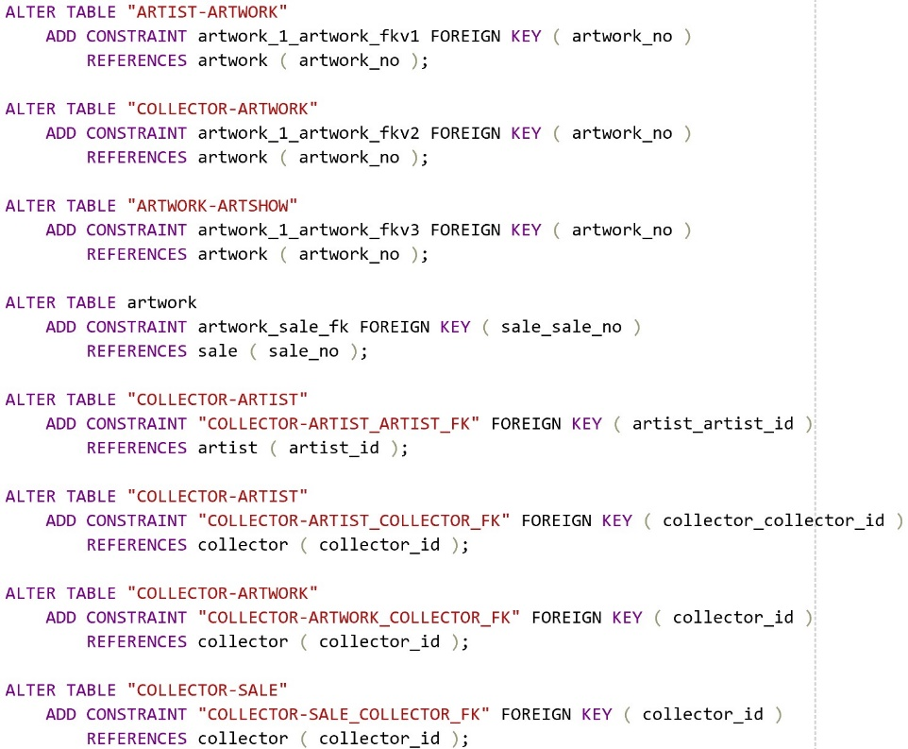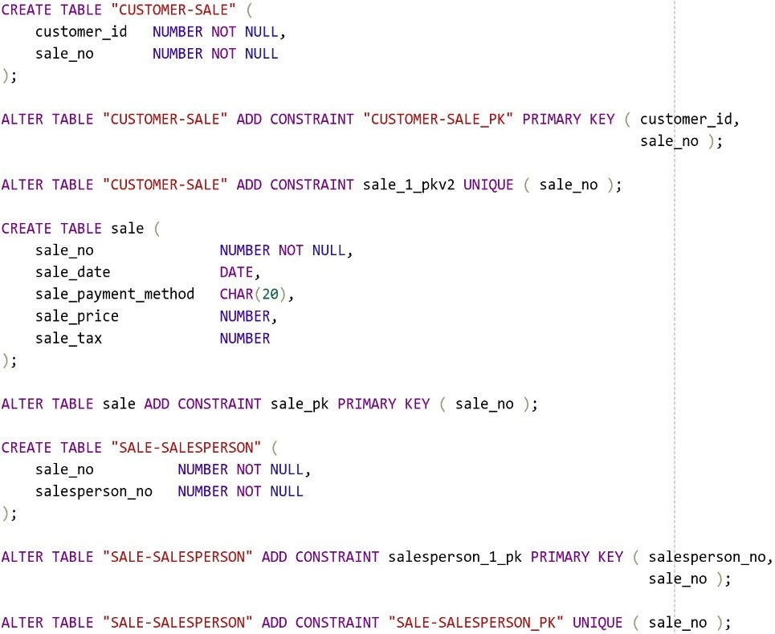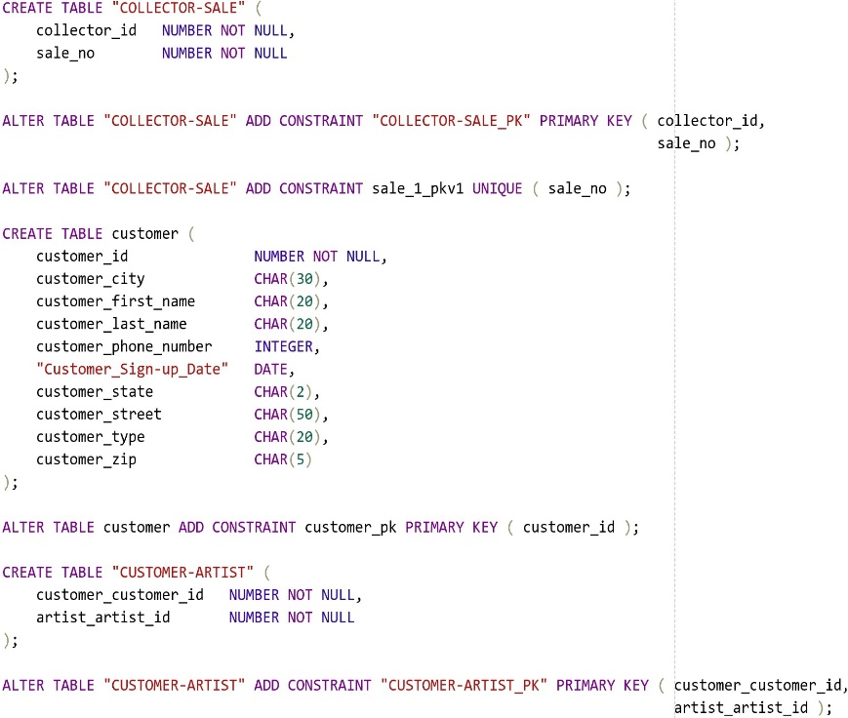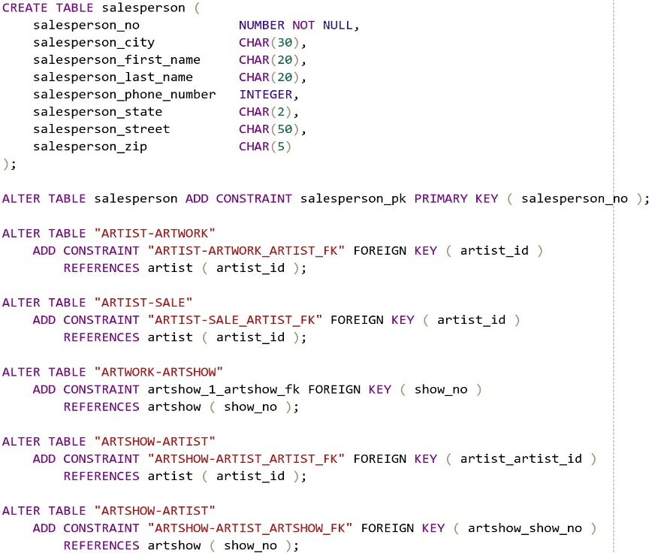

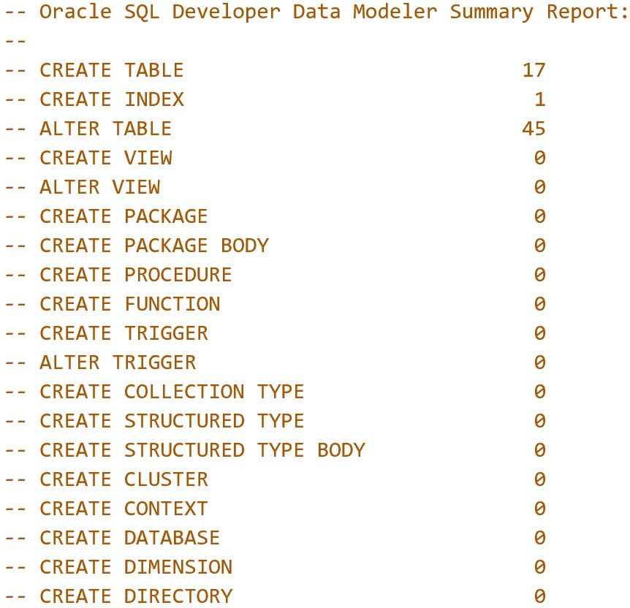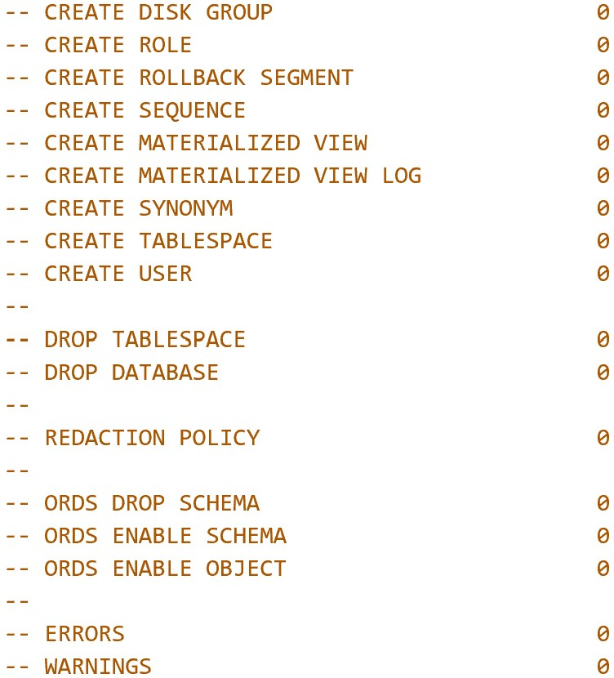

**3.2 Table structures**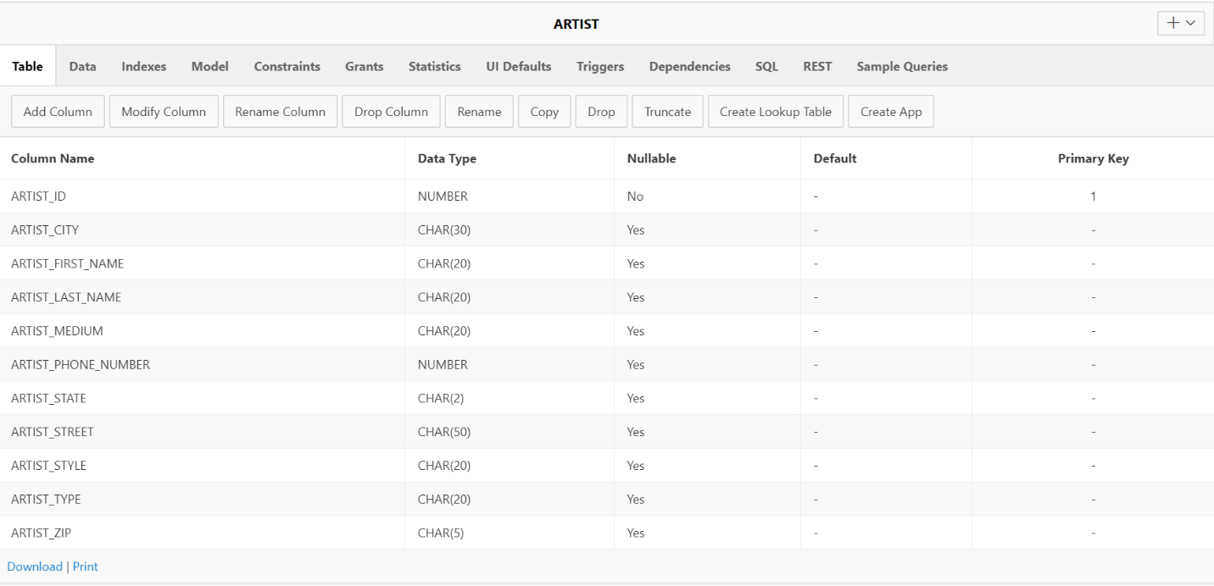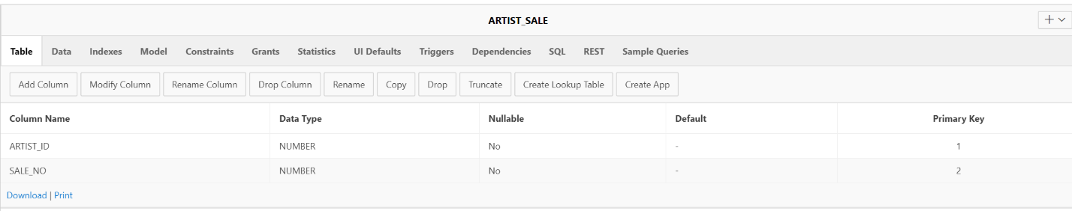

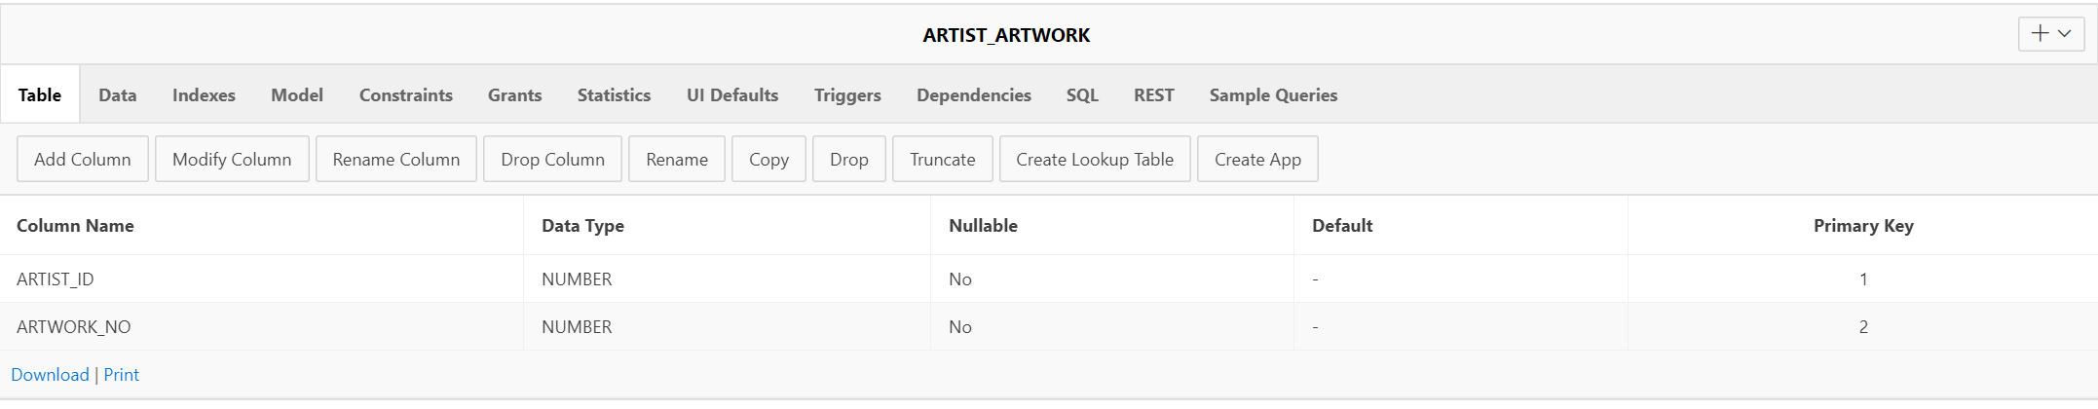

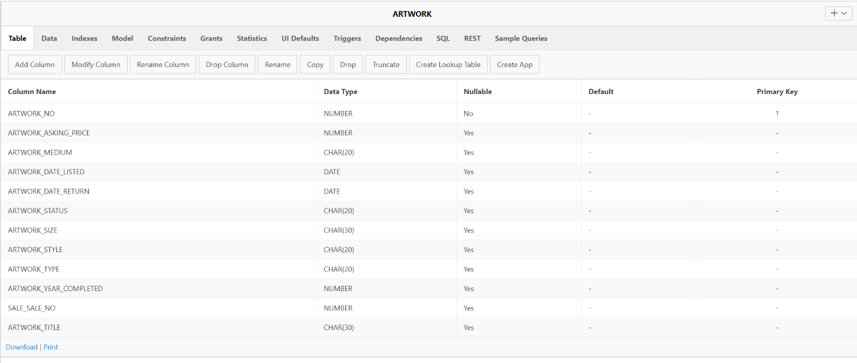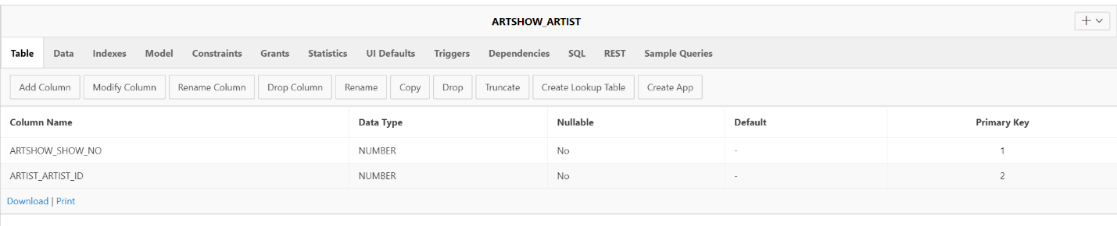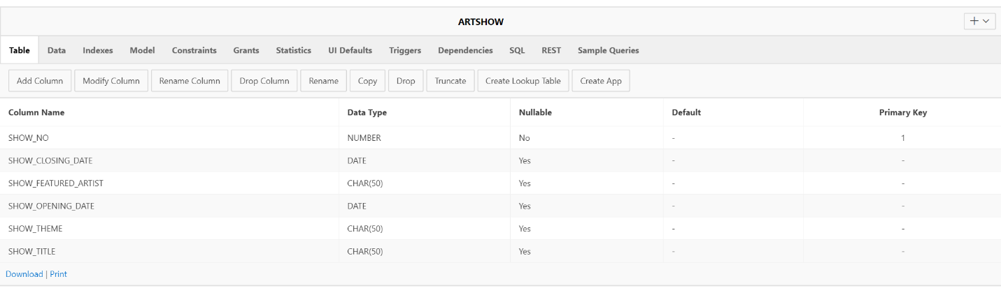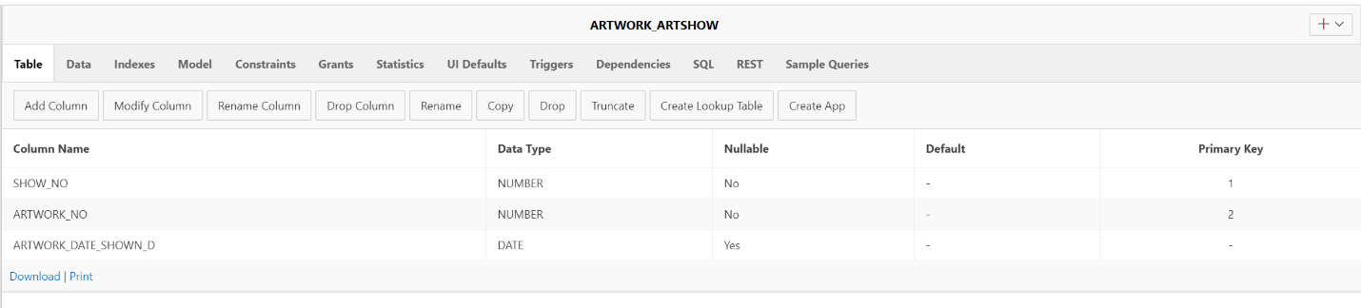

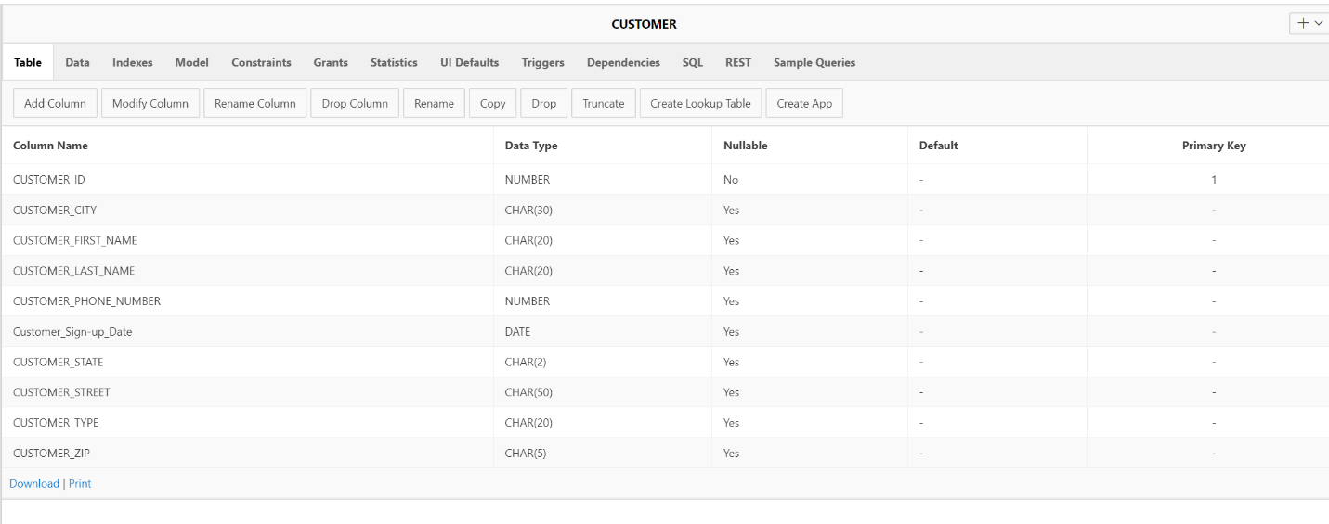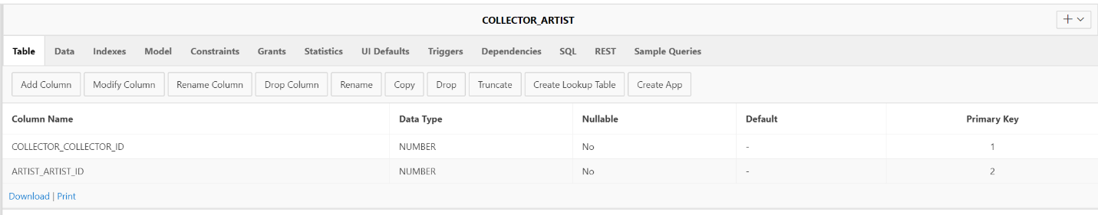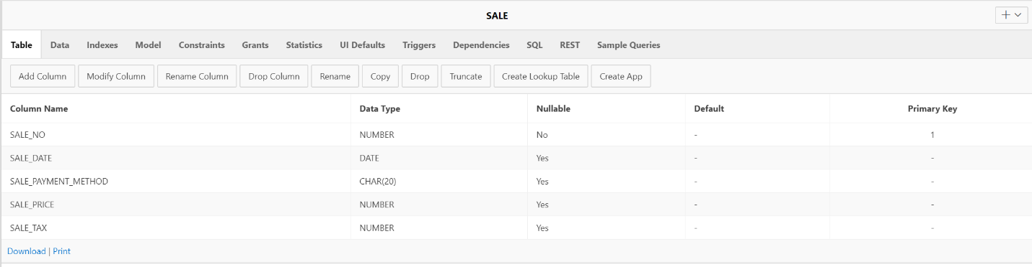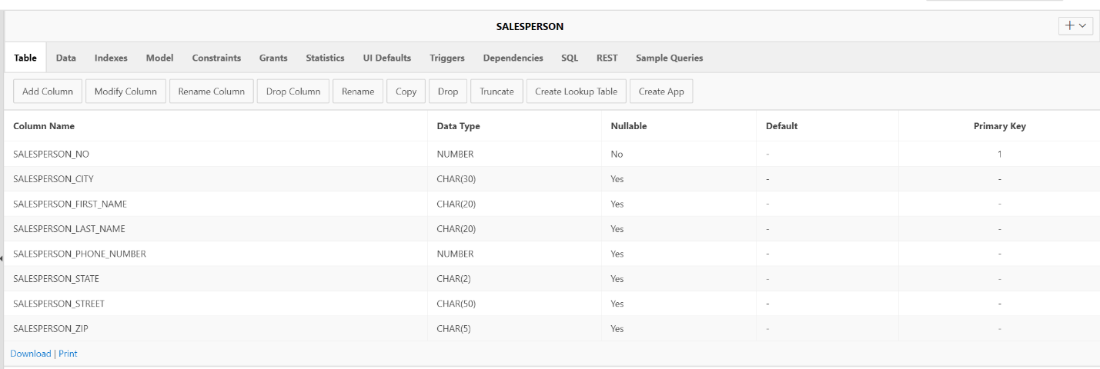

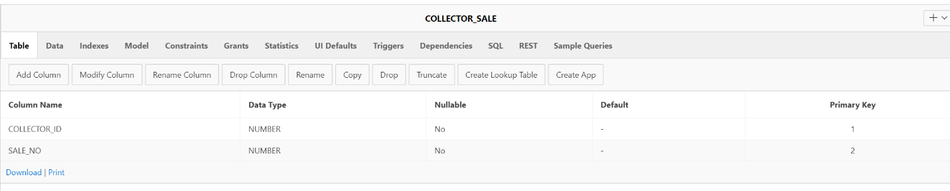

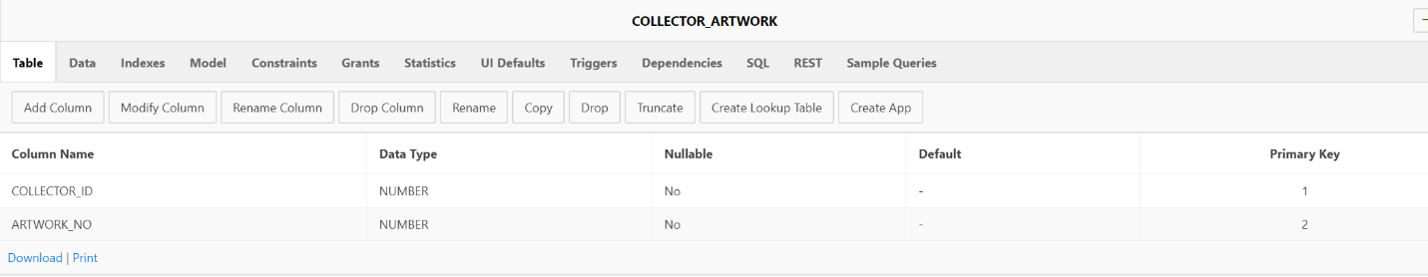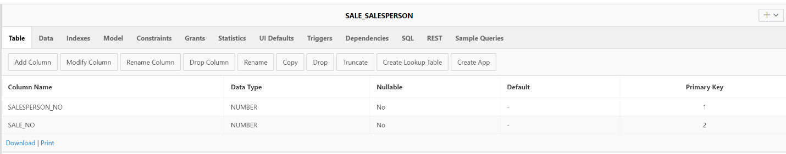

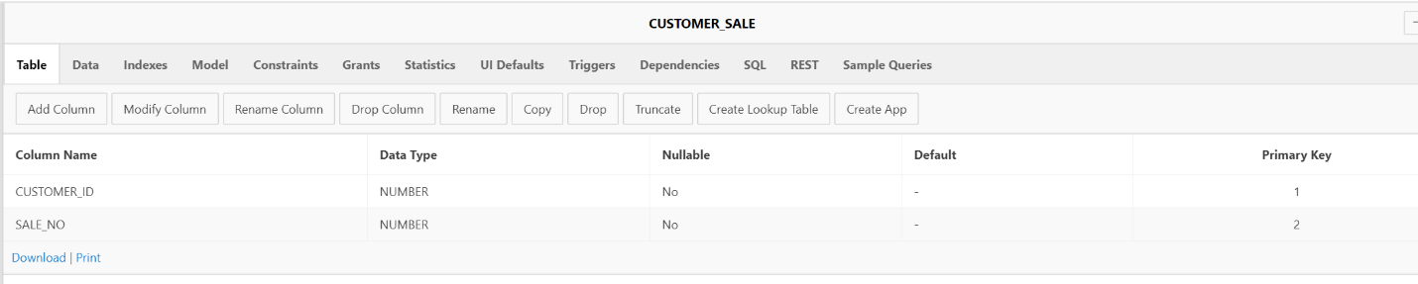

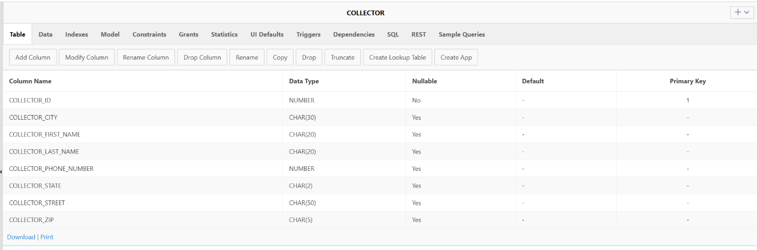

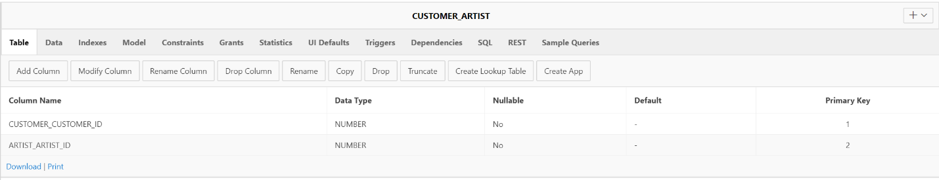

**3.3 Tables with data**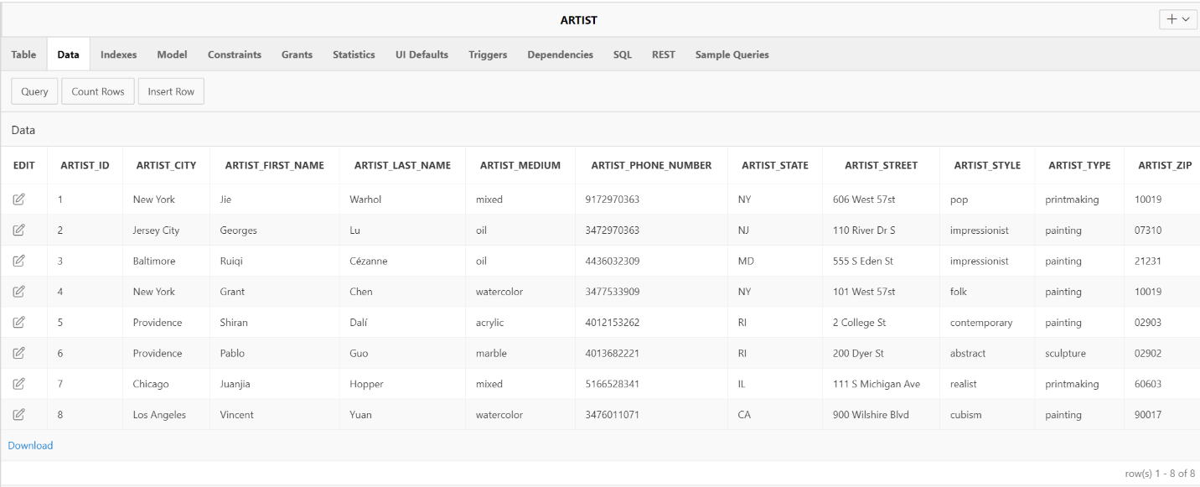

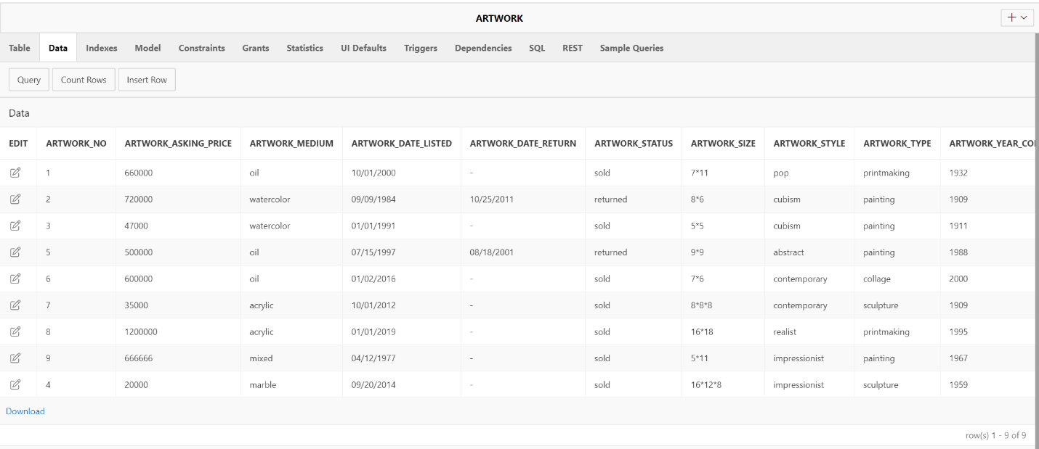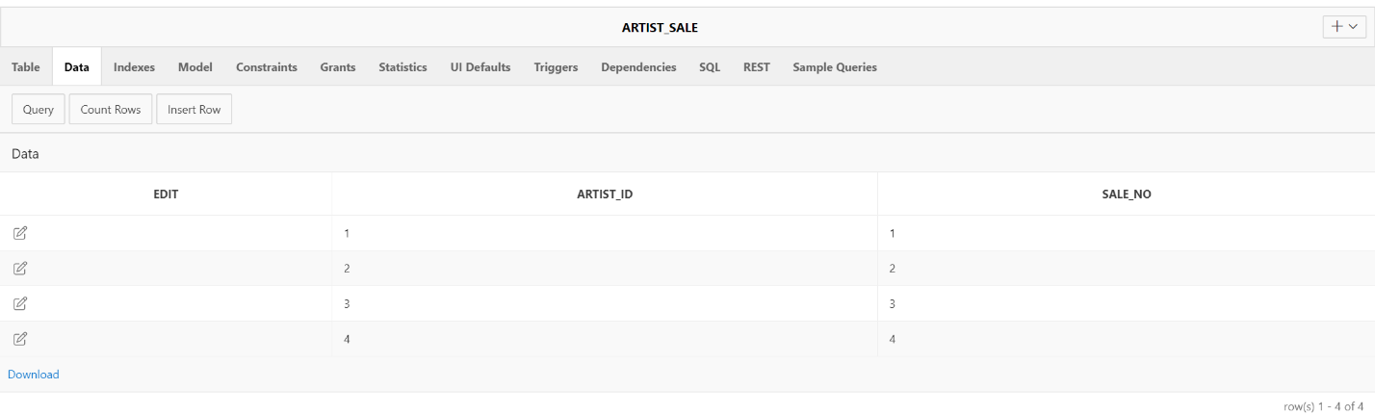

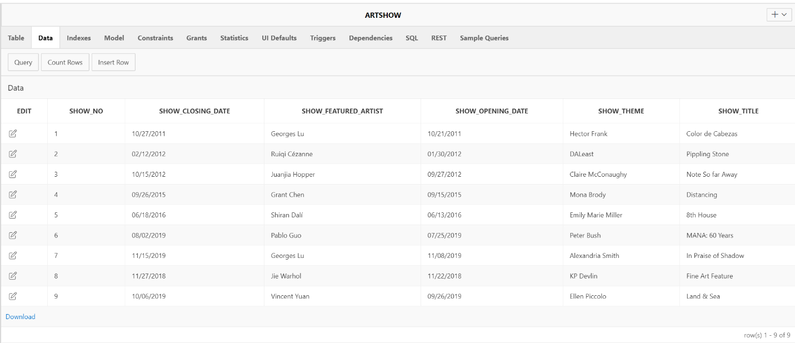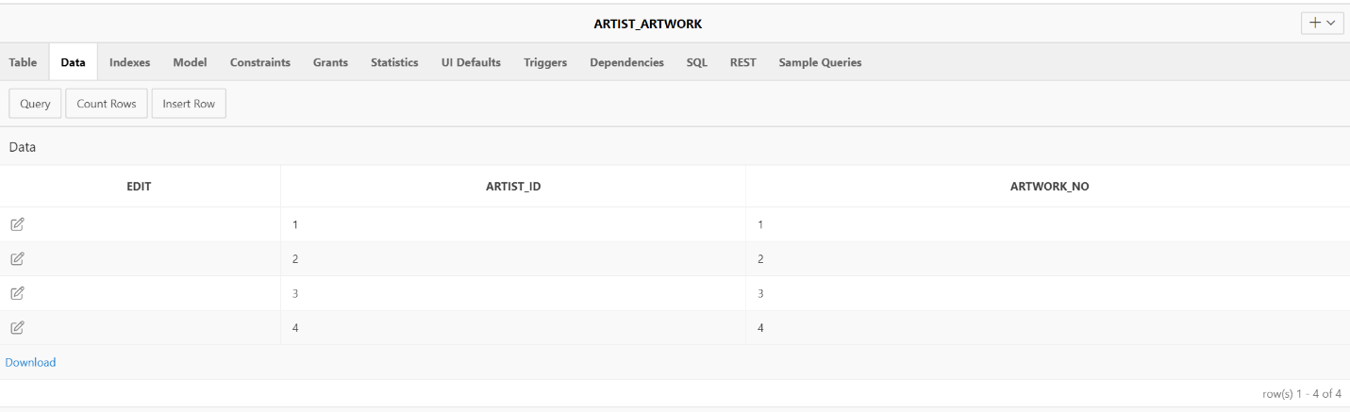

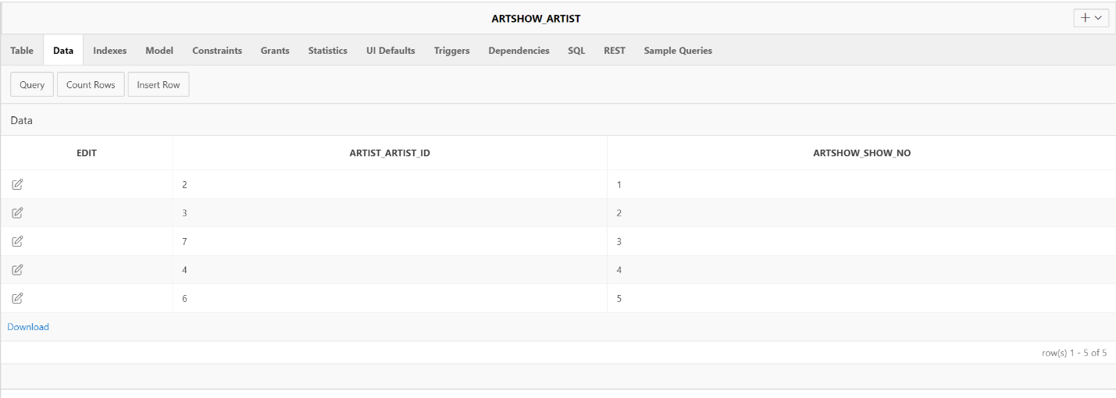

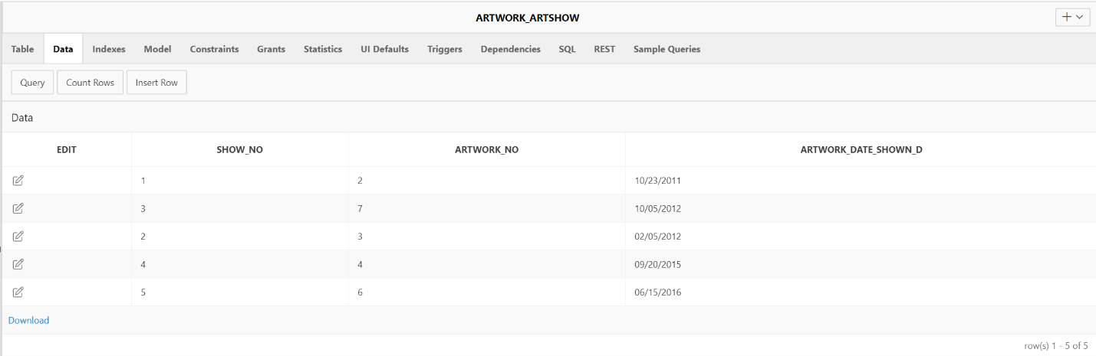

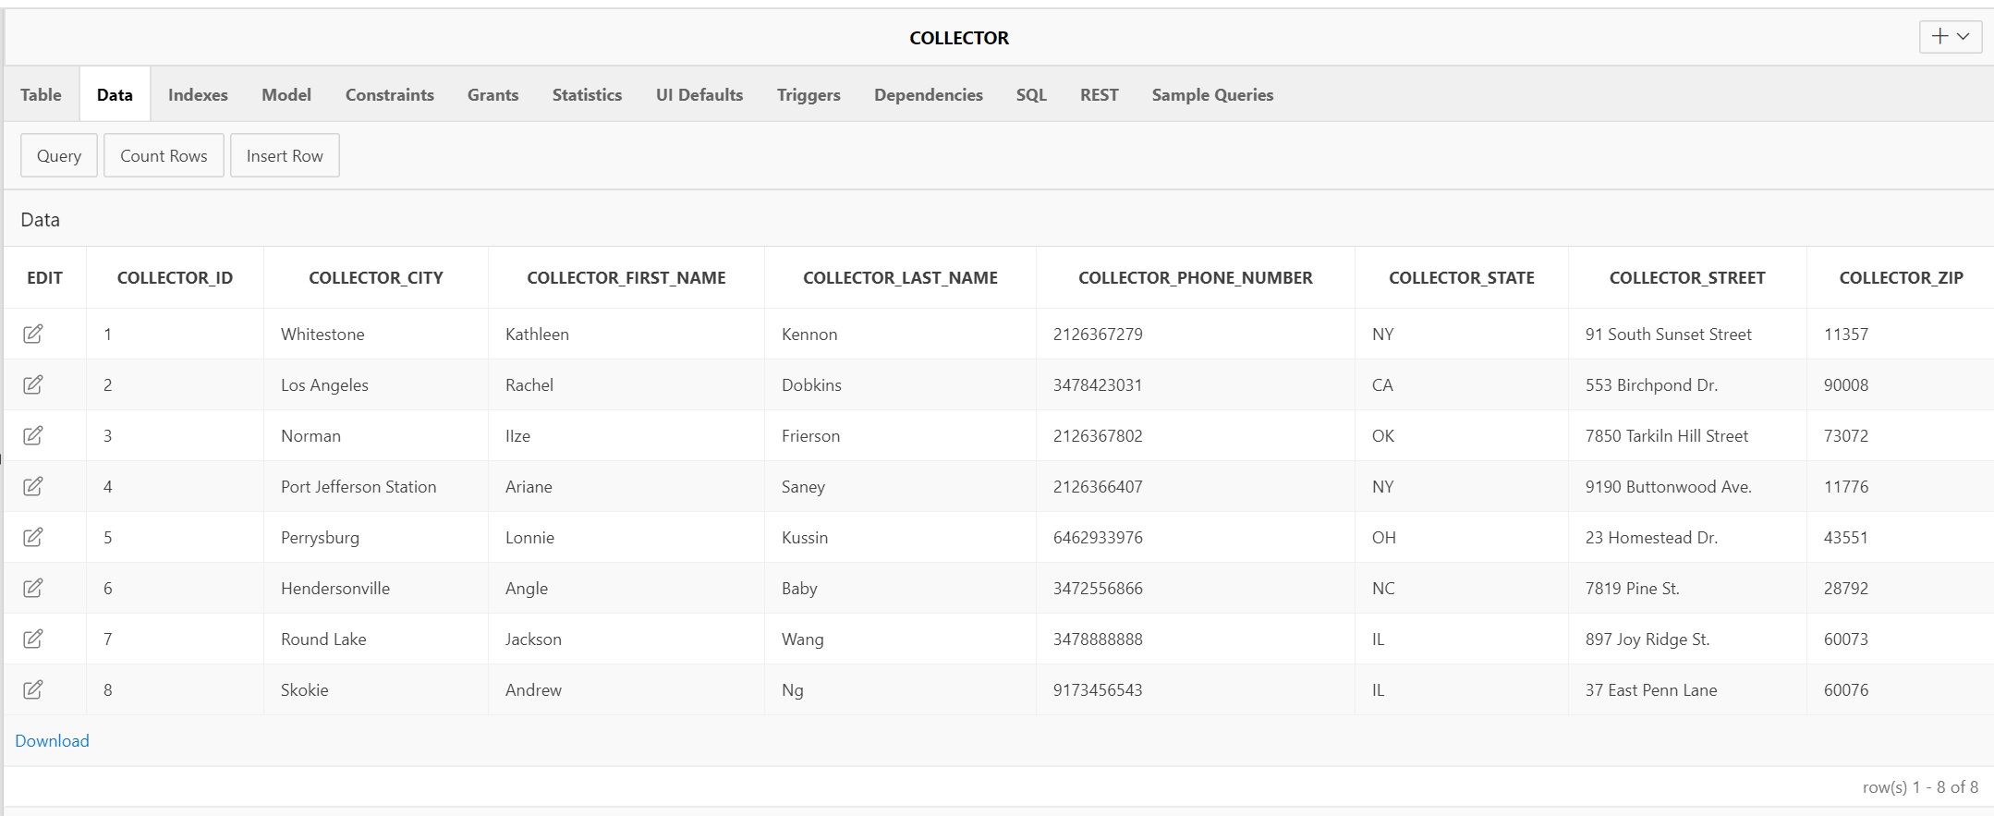

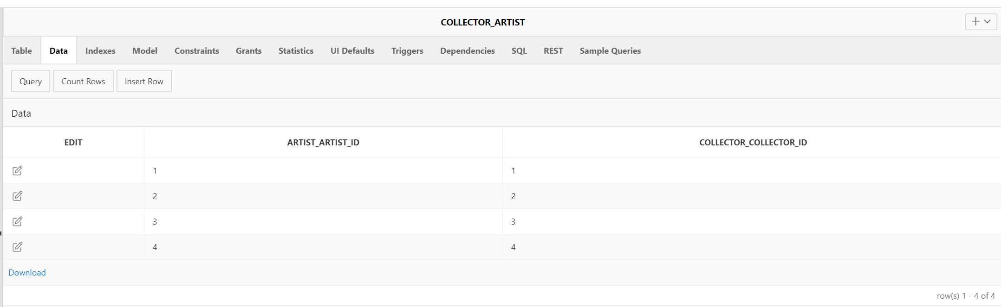

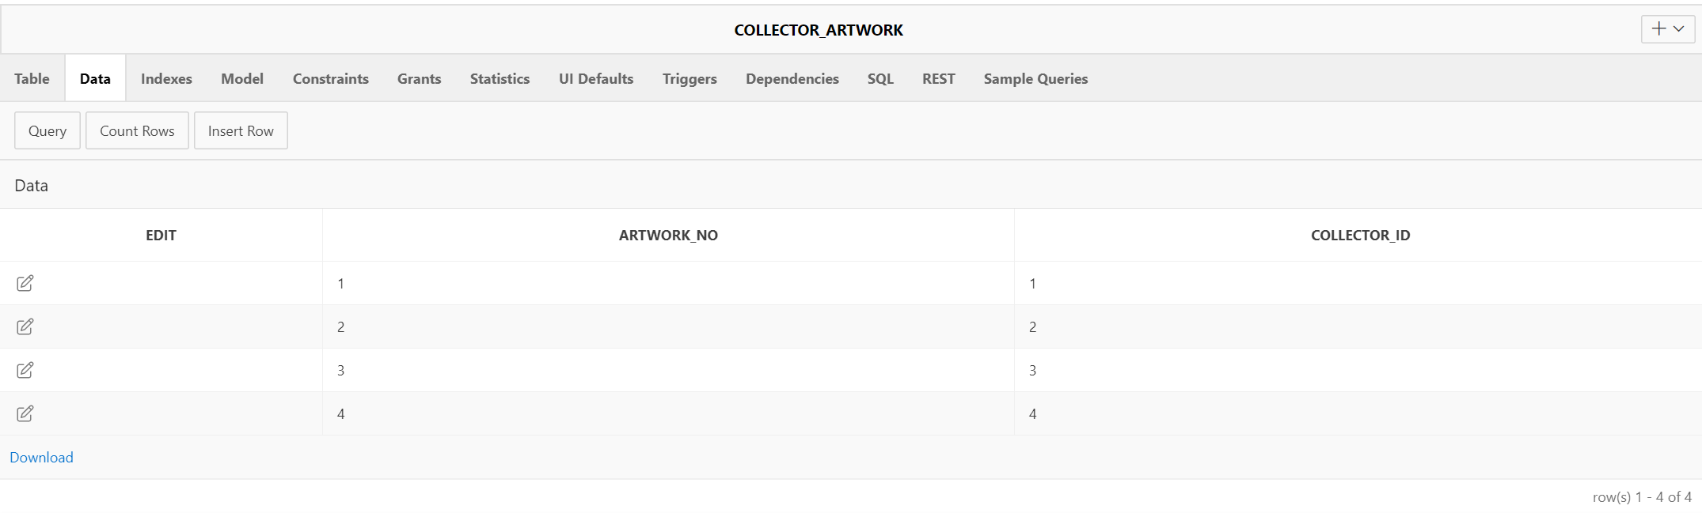

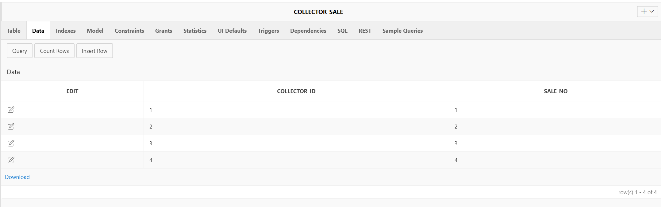

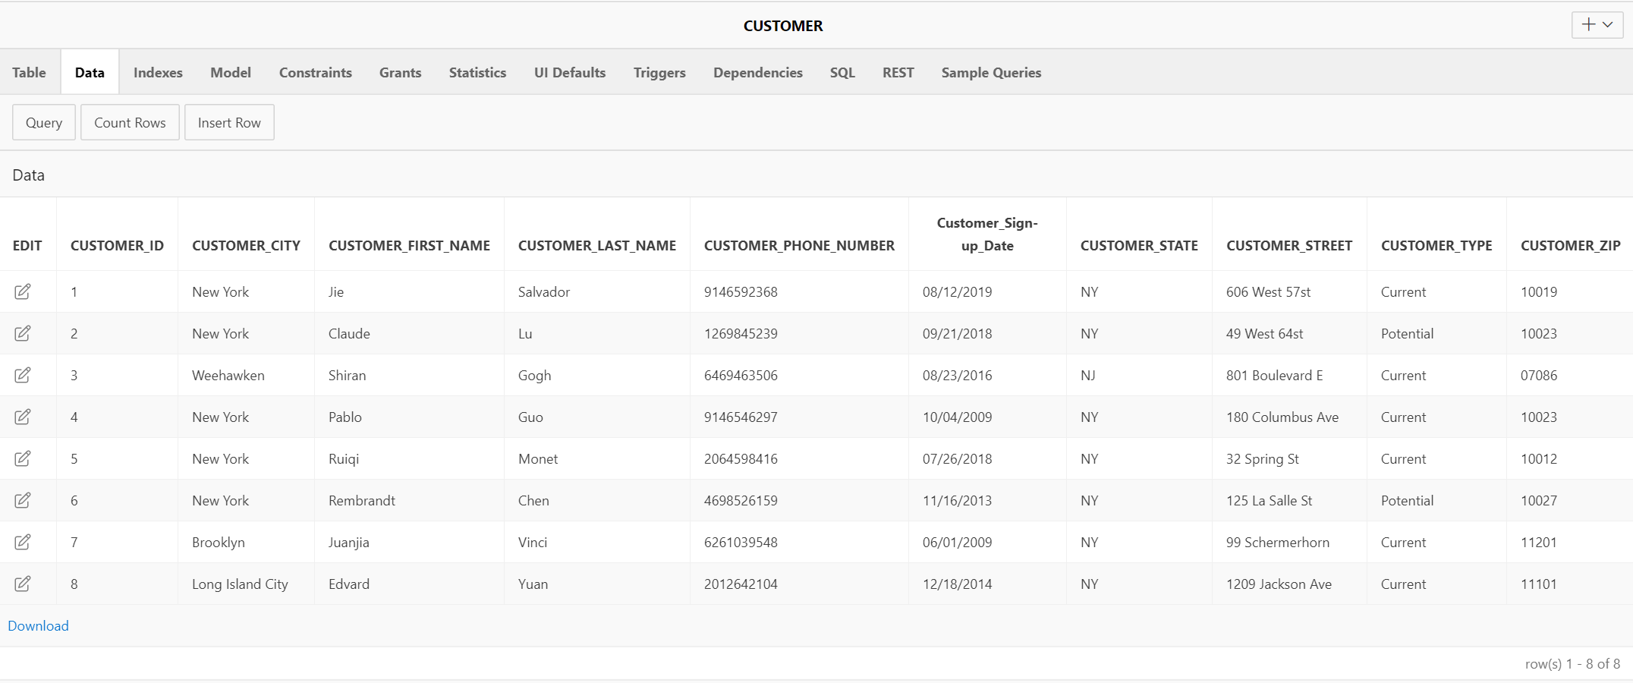

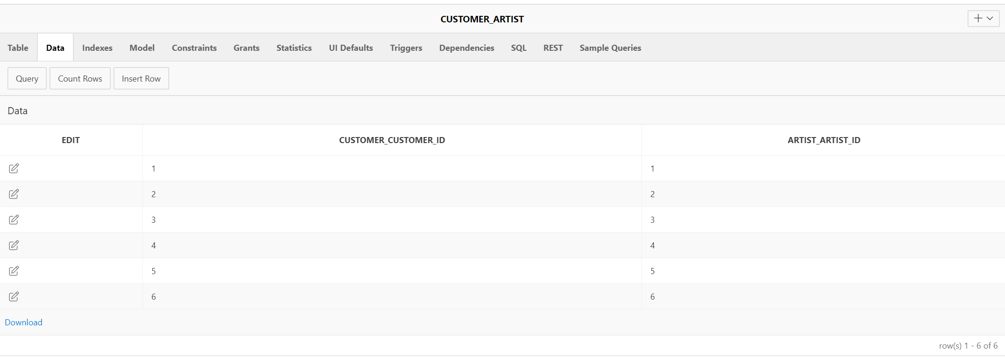

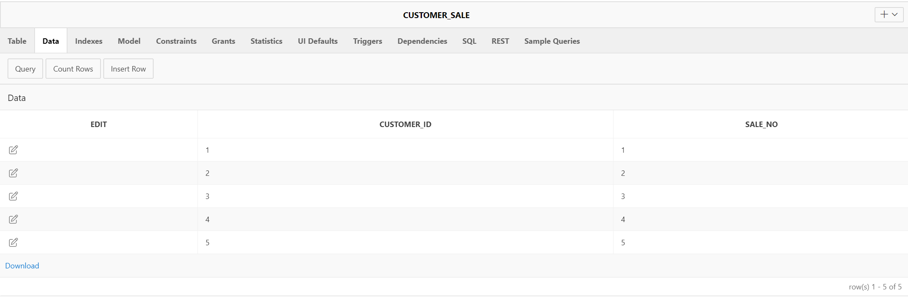

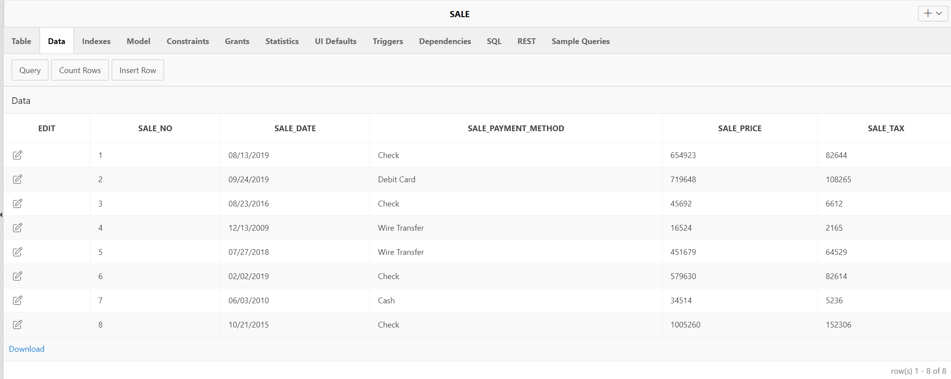

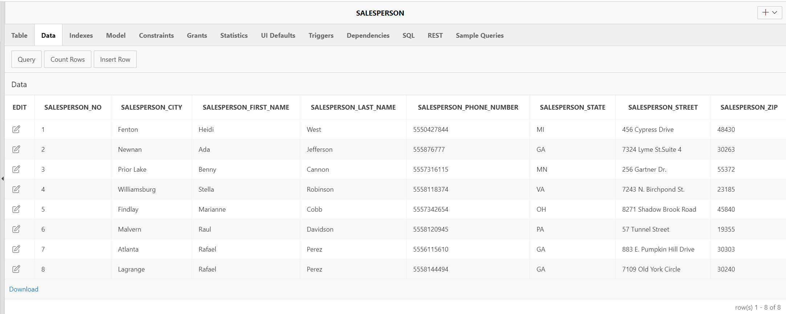

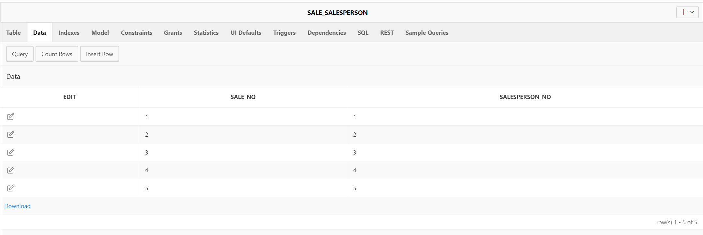

**3.4 The 12 queries**

**1. A multi-table query that links 3 tables related to artist, artwork, and collector information together (minimum of 4 attributes excluding keys).**

**English version:**

Find all artworks, their style, artists and collectors

**SQL version:**

SELECT artwork_title, artwork_style, artist_first_name || artist_last_name AS artist_name, collector_first_name || collector_last_name AS collector_name

FROM artist

JOIN artist_artwork

ON artist.artist_id = artist_artwork.artist_id

JOIN artwork

ON artist_artwork.artwork_no = artwork.artwork_no

JOIN collector_artwork

ON artwork.artwork_no = collector_artwork.artwork_no

JOIN collector

ON collector.collector_id = collector_artwork.collector_id

**Output:**

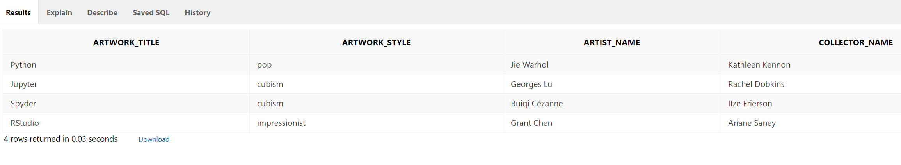

**2. A multi-table query that links 3 tables related to sale, artwork, buyer, and salesperson together (minimum of 4 attributes excluding keys).**

**English version:**

Find artwork title, the customer who bought them and the name of the salesperson they use, and their sales price.

**SQL version:**

SELECT artwork_title, customer_first_name || customer_last_name AS customer_name, salesperson_first_name || salesperson_last_name AS salesperson_name, sale.sale_price

FROM customer

JOIN customer_sale

ON customer.customer_id = customer_sale.customer_id

JOIN artwork

ON artwork.sale_sale_no = customer_sale.sale_no

JOIN sale_salesperson

ON artwork.sale_sale_no = sale_salesperson.sale_no

JOIN salesperson

ON sale_salesperson.salesperson_no = salesperson.salesperson_no

JOIN sale

ON sale_salesperson.sale_no = sale.sale_no

**Output:**

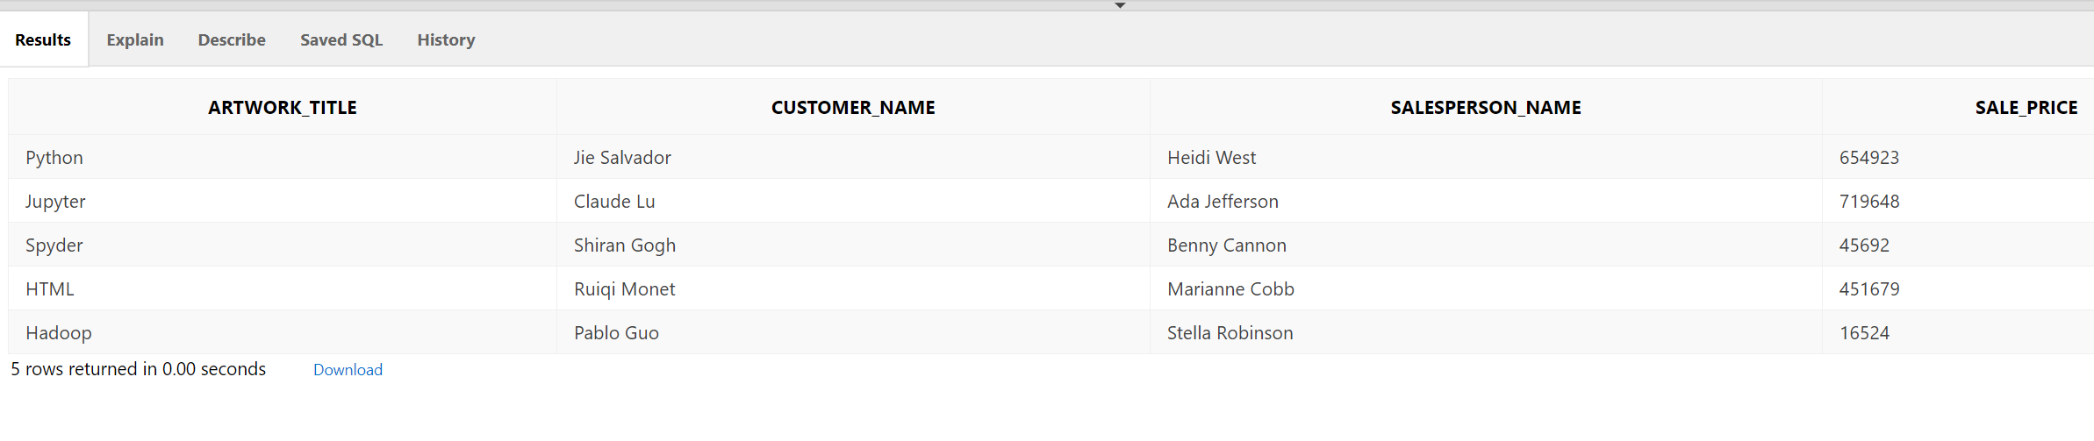

**3. A multi-table query that links sale, artwork, collector and salesperson information. (minimum of 4 attributes excluding keys).**

**English version:**

Find artwork title, the collector who owned them, the name of the salesperson, and their sales price.

**SQL version:**

SELECT artwork_title, collector_first_name || collector_last_name AS collector_name, salesperson_first_name || salesperson_last_name AS salesperson_name, sale.sale_price

FROM collector

JOIN collector_sale

ON collector.collector_id = collector_sale.collector_id

JOIN artwork

ON artwork.sale_sale_no = collector_sale.sale_no

JOIN sale_salesperson

ON artwork.sale_sale_no = sale_salesperson.sale_no

JOIN salesperson

ON sale_salesperson.salesperson_no = salesperson.salesperson_no

JOIN sale

ON sale_salesperson.sale_no = sale.sale_no

**Output:**

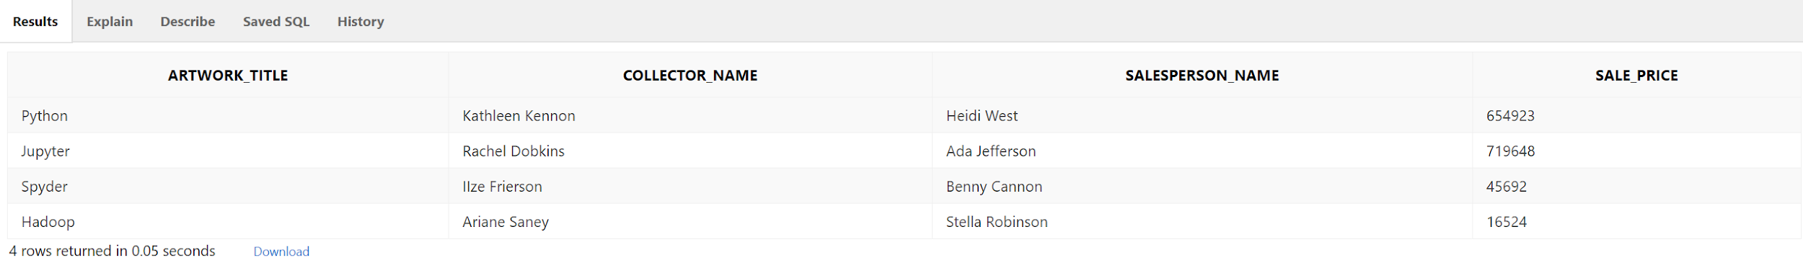

**4. A multi-table query that links artist, customer, artwork and show information together (minimum of 4 attributes excluding keys).**

**English version:** Find all artworks, their customers, artist names and show name

**SQL version:**

SELECT artwork_title, artist_first_name || artist_last_name AS artist_name, customer_first_name || customer_last_name AS customer_name, show_title

FROM artwork

JOIN artist_artwork

ON artwork.artwork_no = artist_artwork.artwork_no

JOIN artist

ON artist.artist_id = artist_artwork.artist_id

JOIN customer_artist

ON customer_artist.artist_artist_id = artist_artwork.artist_id

JOIN customer

ON customer.customer_id = customer_artist.customer_customer_id

JOIN artwork_artshow

ON artwork.artwork_no = artwork_artshow.artwork_no

JOIN artshow

ON artwork_artshow.show_no = artshow.show_no

**Output:**

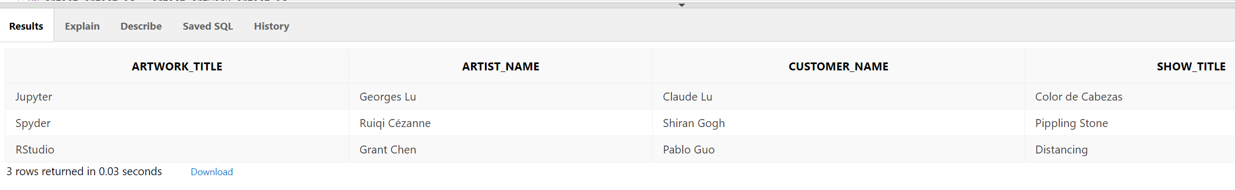

**5. A multi-table (minimum 2 tables) that includes a calculated field.**

**English version:** Which artist has the 2nd most expensive artwork, and the 3rd most expensive artwork?

**SQL:**

SELECT artist_first_name || artist_last_name AS artist_name, sale_price, artwork_title,

RANK() OVER(ORDER BY sale_price DESC) AS ranking

FROM artist

JOIN artist_artwork

ON artist.artist_id = artist_artwork.artist_id

JOIN artwork

ON artist_artwork.artwork_no = artwork.artwork_no

JOIN sale

ON artwork.sale_sale_no = sale.sale_no

OFFSET 1 ROW FETCH NEXT 2 ROWS ONLY

**Output:**

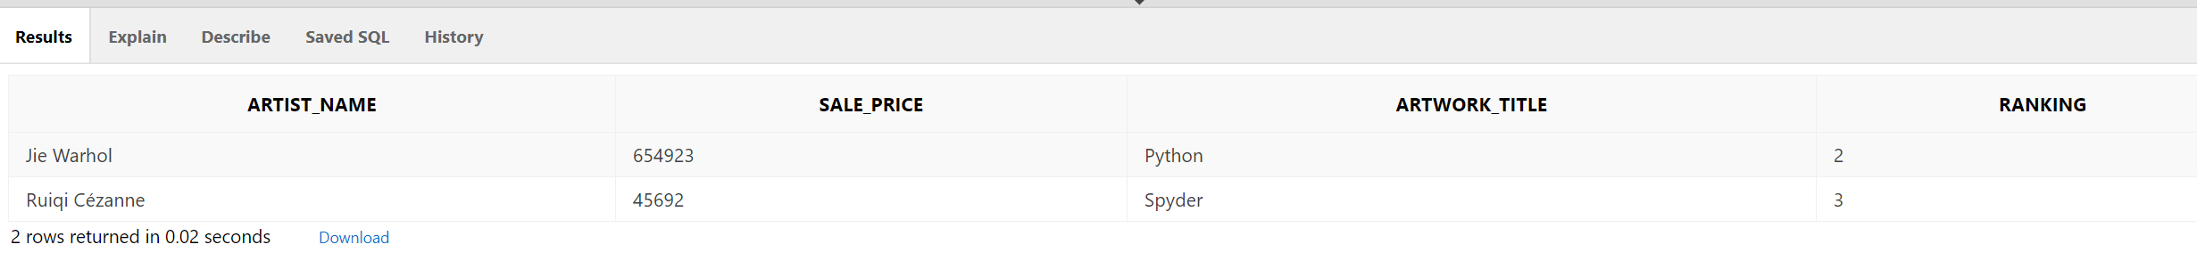

**6. A multi-table query (minimum 2 tables) that includes sorting.**

**English version:**

What’s the average total sale for each artwork type? (Order descendingly)

**SQL version:**

SELECT artwork_type, AVG(sale_price+sale_tax) AS average_sale_total

FROM artwork

JOIN sale

ON artwork.sale_sale_no = sale.sale_no

GROUP BY artwork_type

ORDER BY 2 DESC

**Output:**

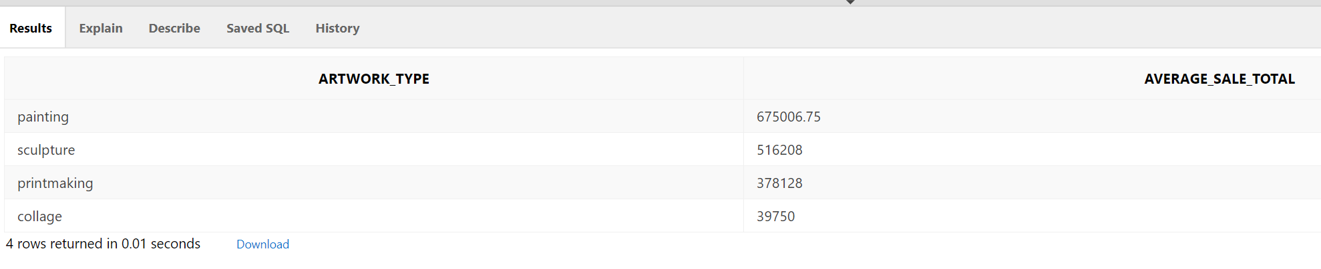

**7. A multi-table query that includes another calculated field.**

**Engish version:**

What’s the average total sale for each artwork style? (Order descendingly)

**SQL version:**

SELECT artwork_style, AVG(sale_price+sale_tax) AS average_sale_total

FROM artwork

JOIN sale

ON artwork.sale_sale_no = sale.sale_no

GROUP BY artwork_style

ORDER BY 2 DESC

**Output:**

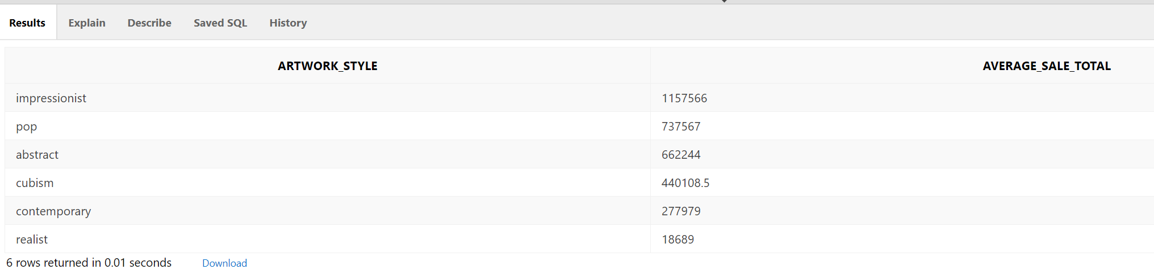

**8. A multi-table query that includes a comparison.**

**English version:**

What artworks are sold above $100000?

**SQL version:**

SELECT artwork_title, sale_price

FROM artwork

JOIN sale

ON artwork.sale_sale_no = sale.sale_no

WHERE sale_price > 100000

ORDER BY 2 DESC;

**Output:**

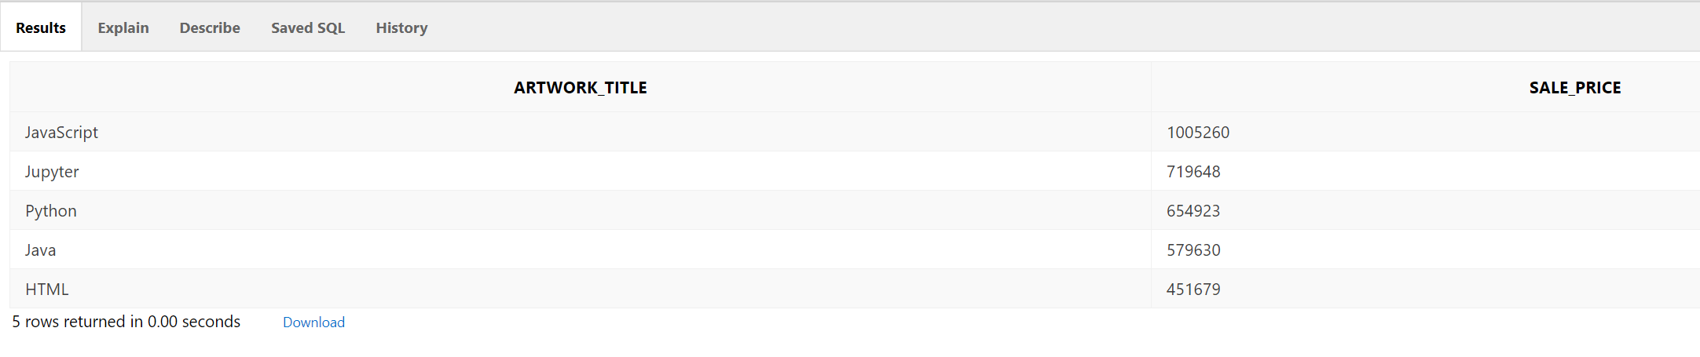

**9. A multi-table query with a date comparison.**

**English version:**

What artworks are sold before 2017?

**SQL version:**

SELECT artwork_title, sale_date

FROM artwork

JOIN sale

ON artwork.sale_sale_no = sale.sale_no

WHERE EXTRACT(YEAR FROM sale.sale_date) < 2017

ORDER BY 2 DESC

**Output:**

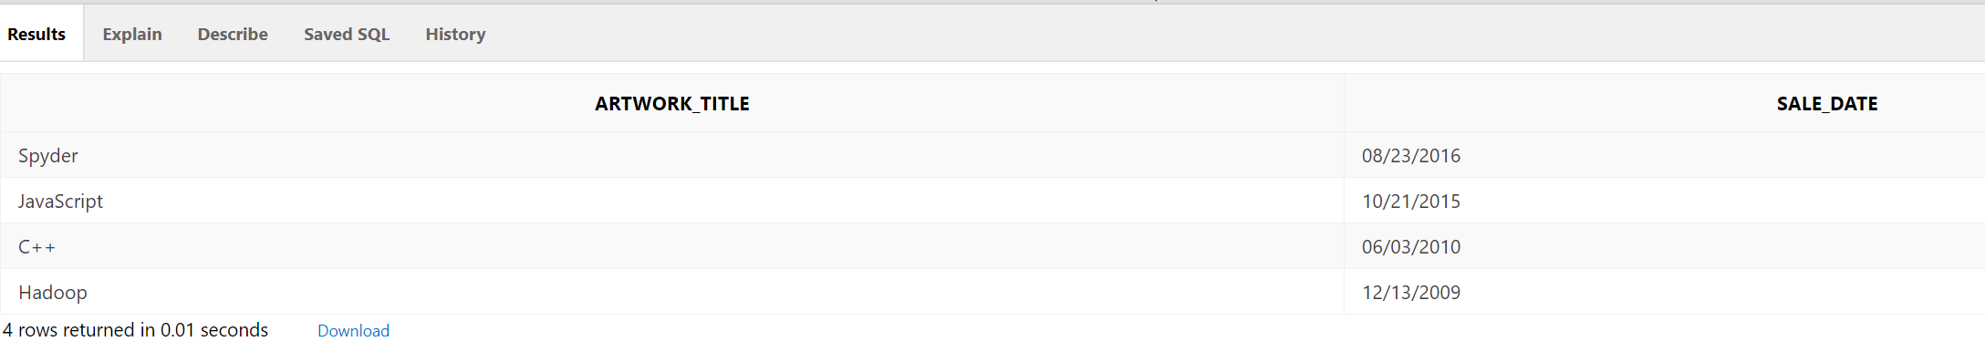

**10. A multi-table query with a count and sort.**

**English version:**

For each artwork type, how many pieces were sold?

**SQL version:**

SELECT artwork_type, COUNT(sale.sale_no) AS amount

FROM artwork

JOIN sale

on artwork.sale_sale_no = sale.sale_no

GROUP BY artwork_type

ORDER BY 2 DESC

**Output:**

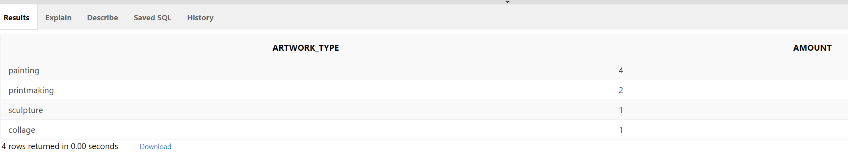

**11. A nested query (with sub query) of your choice.**

**English version:** Find the artists, their zip code and artist usual type for those who are not living in the same state as other pop artists.

**SQL version:**

SELECT artist_first_name || artist_last_name AS artist_name, artist_zip, artist_style

FROM artist

WHERE artist_state NOT IN (SELECT artist_state FROM artist WHERE artist_style = 'pop')

**Output:**

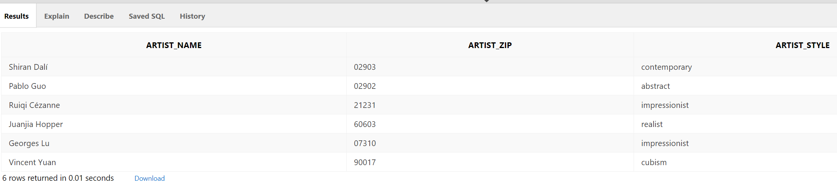

**12. A join query of your choice.**

**English version:** Which salesperson generates most sales?

**SQL version:**

SELECT salesperson_first_name || salesperson_last_name AS salesperson_name, SUM(sale.sale_price+sale.sale_tax) AS total_sales

FROM salesperson

JOIN sale_salesperson

ON salesperson.salesperson_no = sale_salesperson.salesperson_no

JOIN sale

ON sale_salesperson.sale_no = sale.sale_no

GROUP BY salesperson_first_name || salesperson_last_name

ORDER BY 2 DESC

FETCH NEXT 1 ROW ONLY

**Output:**

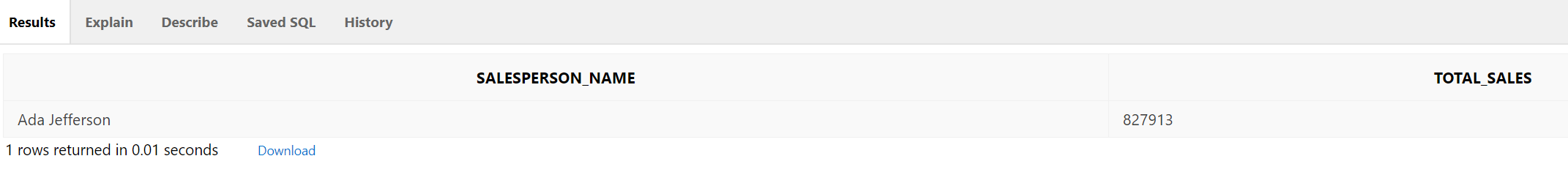

**3.5 Screenshot of database on Apex**

